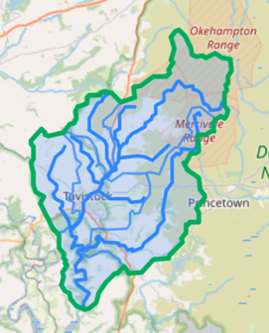
Upstream Thinking is a project funded by South West Water that aims to improve water quality in the Tavy river catchment. Devon Wildlife Trust farm advisors will be working with landowners and managers to tackle issues including soil compaction and erosion, nutrient and pesticide run-off, and flooding. Addressing these issues not only has benefits to water quality, but they also provide many on-farm benefits too, such as improved grass productivity and animal health, and economic savings.

What’s On Offer

Confidential farm advice: Free visit from a farm advisor to offer advice on management of nutrients, soil, pesticides, yard infrastructure, natural flood management, and habitat creation/management.

Soil Aerator: this is available for loan free of charge in the Tavy catchment. It is brilliant at improving drainage and soil structure, and increases productivity on grazing and/or silage ground.

Capital grants: We can provide grants of up to 50% for infrastructure works that improve water quality. These include items such as watercourse fencing, improved slurry and manure storage, roofing feed yards, and silt traps.

Habitat creation and restoration: We can provide advice and capital grants to help create, restore and manage natural habitats, including meadows, wetlands and woodlands.

Woodland Management grants: We can advise on and assist with grant applications for hedgerow and woodland creation and management.

Countryside Stewardship applications: Free advice and full support with applications to the Countryside Stewardship Scheme, Mid and Higher Tiers.
For further information please contact one of our farm advisors:
Rachel Kaleta Email: rkaleta@devonwildlifetrust.org Tel: 07816 342229
David Thomas Email: dthomas@devonwildlifetrust.org Tel: 07935 754875

