Devon Wildlife Trust
(A company limited by guarantee)

Registered charity number 213224

Annual Report and Group Accounts

For the Year Ended 31 March 2020

Registered company number 733321

Contents

Page

Trustees’ Report - Report from the Chair 1

Trustees’ Report 3

Independent Auditor’s Report 28

Group Statement of Financial Activities 31

Balance Sheets 32

Group Cash Flow Statement 33

Notes to the Group Accounts 34

Report from the Chair

As I write this report, Covid-19 has very quickly and fundamentally changed how we live, work, and communicate. It is a difficult and frightening time for many of us as we worry about the safety of friends and family. It is also one of great uncertainty; it is hard to know how this terrible disease, and the steps we have had to take to contain it, will affect us all in the future. But the community spirit shown by many has been heartening and I am lucky enough to have a garden and access to wild places on my doorstep. I have found immense joy and considerable solace in Devon’s beautiful natural environment. It reminds me of why I am so involved with Devon Wildlife Trust; because I believe, passionately, that the enjoyment of a healthy natural environment, rich in wildlife, should be everyone’s right. That connection with nature is fundamental to our health and our happiness. That everyone, no matter what their circumstances or where they live, should have that privilege. And that, in the face of a climate and ecological emergency, we need to act now, and act decisively, to recover nature for all our sakes.

I am proud to say that in 2019/20, Devon Wildlife Trust, with your support, has worked hard to create a wilder Devon and to protect the wildlife we love. Key achievements for the year against our strategic aims are detailed in section 2 of this report, but the following are just a few highlights for me:

- Five years of immensely hard work to bring beavers back into the wild in England concluded with the publication of a ground-breaking Beaver Management Strategy Framework supported by a brilliant and comprehensive Science and Evidence Report. We were absolutely thrilled to hear the government’s decision in early August that the beavers will be permitted to remain on the River Otter and spread to neighbouring catchments. DWT will continue to manage the beavers in Devon for the coming year while the government undertakes a public consultation on a management strategy for beavers in England. The return of these remarkable creatures after an absence of 400 years will help to restore the health of our rivers and create the conditions that will allow a wide range of other rare and threatened species, such as the water vole, to thrive.

- DWT increased its nature reserves from 51 to 58 sites this year and our influence in the wider farmed landscape continued. The Working Wetlands (WW) project completed a 5 year South West Water funded Upstream Thinking programme, working with farmers to reduce pesticide use and diffuse pollution in our rivers, and to restore threatened Culm grassland. The Northern Devon Nature Improvement Area (NIA) initiative, the Devon Greater Horseshoe Bat Project (DGHBP) and Avon Valley Projects also worked with farmers and land managers to restore meadows, hedgerows and a range of vital habitats.
- All of this work is improving the state of our rivers and, this year, the NIA began a new Torridge River Restoration Project. This ambitious project will see over £400,000 in capital works money spent on improving the ecological status of the River Torridge by autumn 2021.

- There has been much work to be done on our nature reserves to respond to ash dieback, a tree disease that will affect 90% of our ash trees. This year the Trust also secured development phase funding from the National Lottery Heritage Fund (NLHF) for Saving Devon’s Treescapes, an ambitious partnership project that will work with communities to counter the impacts of tree loss in our towns and the wider countryside.

- Once again, we have engaged thousands of people through our visitor centres, our education team and our projects, helping people from all backgrounds to access, understand and benefit from nature. And this year we launched an Action for Insects campaign, to worldwide media interest. This campaign has now been adopted by The Wildlife Trusts movement and will continue into 2020/21. It supports ongoing advocacy work to ensure that, post Brexit, we have strong, legal environmental protections and high-level commitment to establishing a Nature Recovery Network and reducing pesticides.
1
- We have continued to run the business to a very high standard and have retained Investors in People, Investing in Volunteers and ISO14001 (environmental management) accreditations. With ever increasing awareness of climate change, the Trust also began to progress plans to achieve its target to be carbon neutral by 2030. At the end of this year, we rapidly put in place business continuity plans in response to Covid-19. The speed and efficiency with which we were able to do this is a testament to the strength of the organisation and its hard-working staff team.

- With a difficult and uncertain year ahead of us, I am also pleased to report that 19/20 was a good year for the Trust financially, thanks, in large part, to our fantastic supporters.

By the time many of you will be reading this, I hope that we will be coming through the worst of Covid-19. But whatever the future brings, we are continuing to fight hard for a wilder Devon and none of our work would be possible without the passion, commitment and tireless work of our staff, local groups, volunteers and partners. It would not be possible without the generosity of our members, grant funders, corporate supporters, donors and those who have chosen to remember Devon Wildlife Trust in their wills. On behalf of the Board of Trustees, I want to thank everyone who has made such a difference to Devon’s wildlife this year and who will make our work possible in the future.

Suzanne Goodfellow
Chair of the Board of Trustees
2

The trustees of Devon Wildlife Trust (DWT), who are also directors of DWT for the purposes of the Companies Act 2006, present their Annual Report (incorporating the Strategic Report), together with the consolidated financial statements of the charity and its subsidiaries for the year ended 31 March 2020.

The financial statements comply with the Charities Act 2011, the Companies Act 2006 and Accounting and Reporting by Charities: Statement of Recommended Practice applicable to charities preparing their accounts in accordance with the Financial Reporting Standard applicable in the UK and Republic of Ireland (FRS 102) (effective 1 January 2015).

1 Aims and Objectives

1.1 DWT’s Charitable Objects as stated in our Memorandum and Articles of Association are:

- To conserve for the benefit of the people of Devon and others, places, objects and creatures of ornithological, entomological, botanical, zoological, geological, archaeological and scientific interest, in particular but not exclusively by promoting the biodiversity of the area of benefit where it shall be charitable to do so;

- To educate the public and in particular to increase knowledge and awareness of biodiversity; and for these purposes the term “biodiversity” shall be defined as meaning “the diversity of animal and plant life”.

1.2 Devon Wildlife Trust’s vision, purpose and mission are set out in its 25 Year Plan. Our purpose can be summarised by the four statements below: -

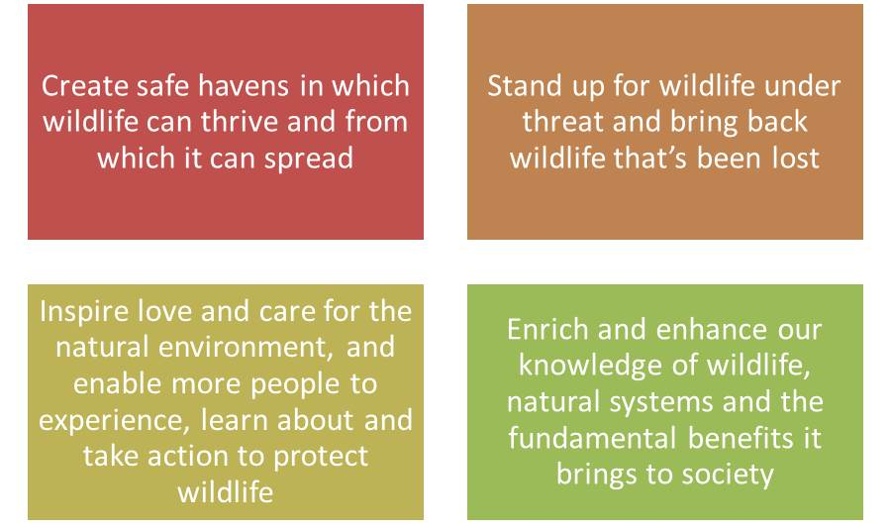

DWT is involved with a wide range of activities, but they can be broadly divided into three principal themes: -

- Living Landscapes: this is based on The Wildlife Trusts pioneering work to conserve wildlife at a landscape scale in the terrestrial environment, responding to the challenges of habitat fragmentation and climate change. At its heart is a conviction that wildlife-rich areas need to be bigger, better, more numerous and better connected. It encapsulates our aspirations for high quality habitats and the recovery of the species they support.
3
- Living Seas: approximately half of our biodiversity resides in our surrounding seas. Yet action to protect marine wildlife is decades behind conservation on land. With ocean environments in alarming decline worldwide and pressure on fisheries growing, it is imperative that we act now if we are to stop these trends before it is too late. Our mission includes designating areas for marine wildlife, managing the activities that take place within them and changing fishing practices so that marine wildlife can thrive in UK seas once again.

- Living with Nature: this embraces our work with people and wildlife. Our aim is to change hearts, minds and behaviour so that people take decisions in the best interests of wildlife and engage with nature to enrich their lives. This might relate to the way people garden, the food they buy, the water they use or the way they spend their leisure time. We are not just looking for passive support; we want many more people to become actively involved with wildlife conservation.

All three themes are supported by our aim to increase our understanding and knowledge base, to share that knowledge with our partners and stakeholders and to put it into practice throughout our work. While driven by a passionate belief in what we do, our mission will be underpinned by good evidence, sound science and a desire to bring people with us.

1.3 Our values and beliefs are what hold us together. They inform how we do our work and what makes DWT and its people the organisation that it is.

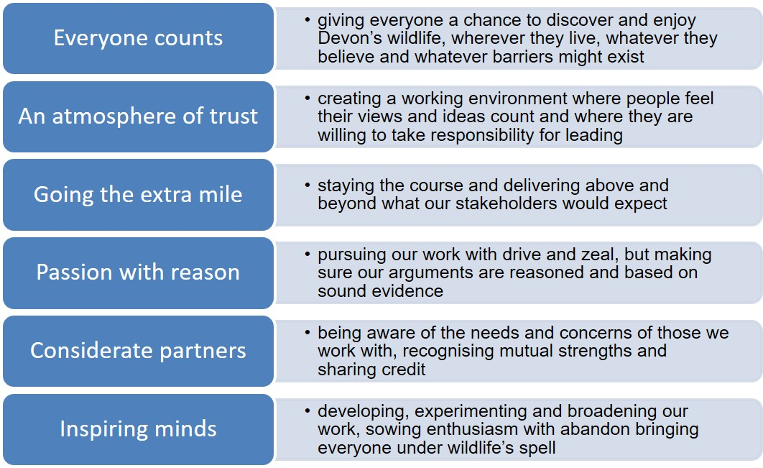

4

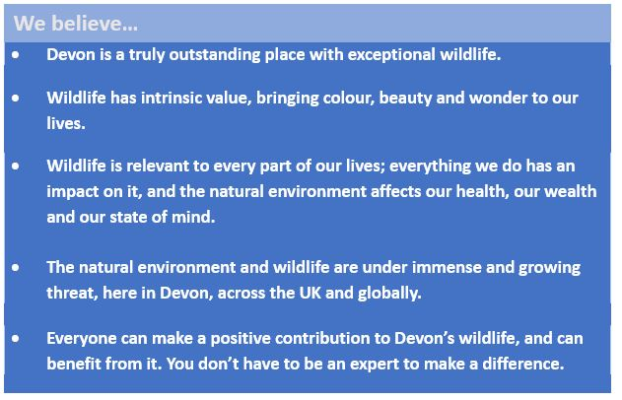

1.3 Our Strategic Plan 2018-2023 supports our long-term vision for a Wilder Devon and sets out the following aims for the Trust:
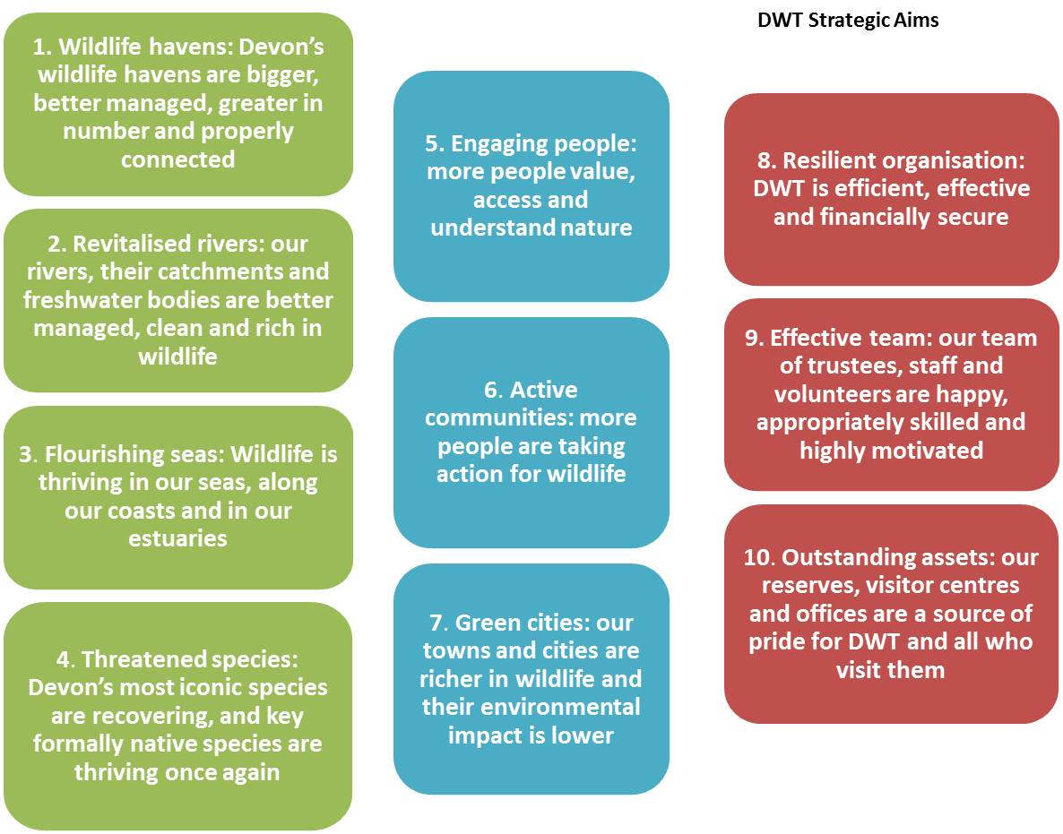

To achieve our objectives, we also aim to enhance our strategic and political influence, to build our science and research base and to grow and diversify our audiences so that the Trust and its work is welcoming and inclusive
5

Much of our work for wildlife is intricately linked to action on climate change. Our habitat restoration work plays a vital role in helping to lock up carbon. Our work with schools and communities features efforts to raise awareness and encourage others to reduce their carbon footprint. As an organisation we do all we can to reduce our emissions through our ISO 14001 accredited environmental system, but we are planning more extensive and radical action on this in the coming year so we can achieve carbon neutrality by 2030 or sooner.
2020 has been a year in which the seriousness of the crises facing nature and our climate have hit the headlines and resonated with the public and politicians as never before. In the coming year we will be thoroughly reviewing our strategic plan and priorities to make sure they are absolutely in tune with this heightened awareness and new sense of collective purpose.
2 Key Achievements against our Strategic Aims and Objectives in 2019/20
6
1. Wildlife havens: Devon’s wildlife havens are bigger, better managed, greater in number and properly connected
Nature reserves
During 2019/20 DWT increased its nature reserves from 51 to 58 sites! 6 Valley Parks in Exeter transferred to DWT. This is a huge opportunity to improve biodiversity right in the heart of Exeter, with over 500,000 visitors per year visiting 143 hectares of land managed for wildlife and people by DWT. Funding has also been secured from Viridor Credits Environmental Company to enable us to make one of the largest sites, Ludwell Valley Park, better for wildlife. With community volunteer support we will create a new pond, expand three woodland areas and create a new meadow in the middle of this busy urban centre. We have also improved signage and site infrastructure. Late in the year Horsey Island in North Devon was successfully purchased thanks to the support of a major donor. This provides a great opportunity to be directly involved in supporting natural coastal processes and developing salt marsh. At year end, again with the help of two major donors, we also acquired additional land adjacent to Lower East Lounston, doubling the size of the nature reserve.

We maintained an excellent management regime of our reserves through 15 Higher Level Stewardship agreements and 6 Higher Tier Stewardship agreements and we have just completed a biodiversity audit of all sites. We have put considerable effort into planning and managing the impacts of ash dieback on our reserves and this will require significant investment by the Trust over the next few years.

Numerous threatened species have benefitted from our nature reserves, including heath lobelia, narrow headed ant, southern damselfly, three-lobed water crowfoot, high brown fritillary, pearl-bordered and small pearl-bordered fritillaries and lesser butterfly orchid.

Overall, the team has managed over 2,000 hectares for wildlife and people, ably supported by active reserve-based volunteer groups across the county. This has only been possible thanks to these hard-working volunteers, a range of grant and charitable trust funders, the generous supporters of our annual nature reserves appeal and the ongoing support of our members.

Influencing the farmed landscape

Working in partnership with land managers and farmers we have made significant gains for wildlife outside our nature reserves. ‘Meadow Makers’ - the Avon Valley Project - worked with 84 local land holders to restore 40ha of meadows, including 9 new sites, thanks to the support of the South Devon Nature Trust and appeal income. With a further 183 farm visits this year, the National Lottery Heritage Fund (NLHF) funded Devon Greater Horseshoe Bat project (DGHBP) has brought 324km of hedgerows into favourable management and improved 1,590 ha of habitat for wildlife. The Northern Devon Nature Improvement Area (NIA) has continued to deliver high quality farm advice and habitat results this year, working with landowners to restore or re-create over 125ha of species rich grassland habitat through the Culm Grassland Natural Flood Management Project funded by the Environment Agency, Devon County Council and the EU’s Interreg 2 Seas fund. We have delivered over 30 workshops for farmers and landowners to share skills and expertise on sustainable land management through the various NIA projects and with the support of the Rural Development Programme for England’s Countryside Stewardship Facilitation Fund.

The Working Wetlands (WW) project completed a 5 year South West Water-funded Upstream Thinking programme, working with farmers to produce 44 farm plans, reduce pesticide use and diffuse pollution in our rivers, and restore 73 hectares of “Culm” mires. Over the 5 years the project has secured over £8 million in Countryside Stewardship agreements for local land holders, including £2.3 million this year. Work took place across County Wildlife Sites to improve condition and to monitor key species including willow tit and marsh fritillary. We are delighted to have secured a further five years of Upstream Thinking funding, expanding the number of catchments that will benefit from this work.

Creating a Devon Nature Recovery Network
This year, DWT and the Devon Biodiversity Records Centre (DBRC) have led the development of the Devon Nature Recovery Network on behalf of the Devon Local Nature Partnership. As a Wildlife Trust movement, we have been lobbying hard for a new Environment Act that supports an England wide Nature Recovery Network (NRN) – bigger, better protected, more numerous, and joined-up habitats where wildlife can thrive again. A successful pilot project to test local approaches to delivering NRNs has been delivered in the Tamar Valley area. There is widespread interest and support from local authorities and other organisations, with funding now being sought to hone our approach and roll this out countywide.

We secured funding from Esmée Fairbairn Foundation for the Caen Wetlands – an innovative and exciting project that will explore the feasibility of securing ‘natural capital’ investments for flood risk management, habitat creation and wider public benefits from a dynamic landscape in North Devon. Further south, the Ottery St. Mary Natural Flood Management project, supported by the Environment Agency, has commenced habitat work to reduce flooding impacts in a local community.

2 Revitalised rivers: our rivers, their catchments and freshwater bodies are better managed, clean and rich in wildlife

Work on our nature reserves, through the NIA Culm Grassland Natural Flood Management project and through the efforts of our Working Wetlands advisors has had a direct impact on the health of our rivers and catchments. By supporting landowners to manage land and soils sustainably, the levels of fertilisers, pesticides, and other diffuse pollutants can be reduced substantially. Our work also helps ensure flood peaks are reduced and base flows are enhanced during periods of drought. A new Torridge River Restoration Project, funded by a Water Environment Grant through the Rural Development Programme for England and the Environment Agency, has allowed us to target river improvements where they are most needed. This ambitious project will see over £400,000 in capital works money spent on improving the ecological status of the River Torridge by mid-2021.

DWT hosts two catchment partnerships – North Devon and East Devon. These have been at the forefront of securing collaborative effort to enhance rivers and waterbodies. Most recently we have overseen a number of workshops to secure community engagement in the Environment Agency Challenges and Choices consultation.

3 Flourishing seas: Wildlife is thriving in our seas, along our coats and in our estuaries

The big success of the year was helping to secure a further 15 Marine Conservation Zones (MCZs) around the Devon coast. This is a huge step forward for marine wildlife and would not have happened without fantastic support from our members and supporters. Work is progressing to ensure their effective management, and we will continue to push for further MCZs to protect mobile species such as the white-beaked dolphin and other cetaceans.
7

Working with the Devon and Severn IFCA (Inshore Fisheries and Conservation Authority), our campaign to halt wrasse fishing has helped to ensure byelaws are in place and we have commenced work on calling for otter guards on inshore lobster pots and bait nets to avoid otters drowning. We are also providing input and support on the South West bottlenose dolphin project. We continued to support the development of a South Devon National Marine Park, which aims to enable wider engagement with the marine environment and the numerous designations around Plymouth Sound, together with better links to business.

We have continued to push for a better understanding of our marine environment and a higher level of engagement with our marine heritage through a wide range of activities at our Seaton Jurassic and Wembury visitor centres (see below). These activities have been aimed at people of all ages and abilities. We submitted a significant funding proposal to develop marine engagement activity across the county this year but were unfortunately unsuccessful. Finding sources of funding for our marine work is an ongoing challenge for DWT.

4 Threatened species: Devon’s most iconic species are recovering, and key formerly native species are thriving once again

The River Otter Beaver Trial (ROBT) successfully published the findings of the five-year Trial in January 2020 through a detailed Science and Evidence Report. This is a ground-breaking piece of work and has involved a wide range of partners and stakeholders. Another key output from the Trial, the Beaver Management Strategy Framework, funded by Defra, was published in summer 2019 and set out how beavers should be managed in the future, to maximise their benefits to society and ecology and minimise conflicts.
In early August the government announced that the beavers could remain on the River Otter and spread to neighbouring catchments. This landmark decision is one of the most important in UK conservation history. Much work still needs to be done to secure a high quality management strategy for these animals as they spread across Devon and England, but there is now real hope that our rivers can start functioning more naturally, with huge benefits to a wide range of other rare and threatened species, such as water vole. We cannot thank all of our generous supporters and partners enough for making this possible. For those who are interested in our beaver work, the report can be found on our website.
Devon is the northern European stronghold for greater horseshoe bats. Our Devon Greater Horseshoe Bat (DGHBP) project – supported by NLHF, a range of grant and trust funders, (including The Halpin Trust with £10,000 this year), generous individual supporters, and an extensive and supportive partnership – has worked hard again this year to create conditions where this charismatic species can survive and, in time, thrive. Land advisors made significant gains in wildlife habitat improvement (see earlier in this report) and the project team and partners have supported delivery of 58 ‘BatWorks’ projects – providing capital grants ranging from roost creation to meadow planting. The project saw the accreditation of two towns as ‘bat friendly’, distributed bat buddy school awards and delivered 27 bat festival events. The Devon Bat Survey was hugely successful again, with over 800 participants. A new bespoke greater horseshoe bat roost in East Devon completed this winter has already been populated with lesser and greater horseshoe bats - a great success in an area where the current maternity roost is falling into disrepair. The specification for this roost is being fed into best practice mitigation guidance for planners and developers. Overall, the project engaged 4,065 people in events this year, 735 school children and 1,400 volunteers. Project funding ends in 2020/21 and we are working hard to find further funding to continue key strands of its work.
This year we secured Round 1 funding from the NLHF for Saving Devon’s Treescapes, a partnership project we are leading on behalf of the Ash Dieback Resilience Forum that will help us to tackle the devastating loss of ash trees in Devon’s towns and the wider countryside. This was complemented by funding from local authority partners and a Tesco Bags of Help Centenary Grant.
8
At the end of this year, work commenced to explore the feasibility of pine marten reintroduction via the Two Moors Pine Marten project. This is a partnership project with both National Parks, National Trust and Woodland Trust. Vincent Wildlife Trust has been commissioned to carry out the scientific feasibility study which will report in summer 2020.
9
5 Engaging people: more people value, access and understand nature
DWT engaged and inspired thousands of people this year through our nature reserves, our conservation projects and our visitor centres.
Wembury Marine Centre saw 18,060 visitors to the Centre and delivered 45 sessions to schools and 81 events to public and private groups. Our work helped to open thousands of eyes to the unique and special marine environment of Wembury through rockpool rambles, snorkel safaris, holiday clubs and the Wembury BioBlitz. The BioBlitz was a major highlight of the year. Funded by the National Lottery Community Fund’s Awards for All scheme and run in partnership with the Marine Biological Association, the event engaged 615 people over two days and recorded over 1,000 species.
Seaton Jurassic had 35,449 visitors, 16,591 of whom paid to visit the exhibition. 61 volunteers were involved with the centre, logging 2,933 hours between them. 1,810 school students visited the Centre in 33 organised groups. 93 events for families and other non-school groups were held over the year, a 24% increase on the previous year. Several life-size creature models were installed outside the building, including a prehistoric pliosaur for children to play on, funded by Tesco’s Bags of Help scheme.
Cricklepit Mill – our head office – attracted an estimated 1,800 visitors. The wildlife garden is becoming increasingly popular and, thanks to our hard-working volunteer garden group, achieved ‘outstanding’ status once again in the RHS & Britain in Bloom ‘It’s Your Neighbourhood’ awards. Our Exmouth Local Group were also in receipt of an RHS award for their stunning community garden.
General events, mainly run by our fabulous Local Groups, attracted over 4,000 people (this does not include activities at Wembury, Seaton or events run through our projects), helping them to connect with, learn about and be inspired by nature. We remain hugely grateful for the passion and commitment of our Local Group members.
Our work with schools continued to a high standard thanks to funding from the players of the People’s Postcode Lottery, through which 43 schools are part of our Wildlife Champions network. We reached 12,000 students and 500 individuals via our education activity. The South Devon Wildlife Champions project (funded by South Devon Nature Trust, Education Technology Trust and donations), worked with ten schools and had contact with over 200 students, who engaged in a range of projects within their communities, such as developing insect habitats or mini ponds in their school grounds. The Nature Improvement Area team worked with Beaford Arts on their Community Trails project (funded by NLHF) where six primary schools in North Devon developed landscape trails linked to the photographic archive of James Ravilious and Roger Deakins. Work commenced on a new Nature Friendly Schools national project, led by The Wildlife Trusts (TWTs) and funded by Defra, Department for Education and Natural England, which will reach even more children (especially those from disadvantaged backgrounds) and train teachers in outdoor learning with nature.
We continued to promote the positive impacts of nature on wellbeing through two Sport England-funded projects. The first two cohorts of Flourish in Nature – a partnership project led by the EDP Drug & Alcohol Services to support individuals recovering from addiction – were supported through ten sessions. Connecting Actively with Nature (CAN) – led by Active Devon for the Local Nature Partnership to encourage older individuals to get active in nature – delivered sessions including Nordic walking and Tai Chi in the Valley Parks.
6 Active communities: more people are taking action for wildlife
Thousands of people have taken action for wildlife through our conservation and engagement projects, forming bat friendly communities, managing farms and holdings for wildlife with our support, participating in vital citizen science activity and taking action to make their urban green spaces better for wildlife. We continue to campaign to influence policy and legislation for the benefit of the natural environment, work in schools to inspire young wildlife champions, and recruit and support regular volunteers who help the Trust in all sorts of ways.
This year much of our campaign work focused on securing a strong Environment Act and to ensure that nature’s recovery is a priority in other key areas of legislation, such as the Agriculture and Fisheries Bills. In November we launched Why Insects Matter authored by Professor Dave Goulson which attracted enormous and worldwide media interest. This marked the first phase of Action for Insects – a campaign developed by the South West Wildlife Trusts (SWWTs) to highlight alarming insect declines and encourage people at all levels of society to reduce the unnecessary use of pesticides and to create more insect-friendly habitat. 3,500 people pledged to take action during this phase, and the campaign has now been adopted by The Wildlife Trusts (TWTs) with DWT leading campaign planning. The next phase will run throughout 2020. A further 4,000 people were engaged by DWT in campaigning activity this year, participating in consultations and getting involved in 30 Days Wild, an annual TWT initiative encouraging people to engage in ‘random acts of wildness’ every day in June.
We secured funds from NLHF for Conservation Communities, a project that will involve communities in rural Torridge with citizen science activities to enhance knowledge of biodiversity in these areas and to help local people engage with wildlife on their doorstep.
We continued to deliver the Wild Paths project, led by Dorset Wildlife Trust and supported by NLHF, supporting two trainees at Meeth Quarry nature reserve. Our long-term volunteer programme, based at Woodah Farm and funded by the Phoebe Wortley-Talbot Charitable Trust, trained and supported a further three full time conservation volunteers this year. Our over 300 fantastic regular volunteers have continued to support our work in many ways.
It was a terrific year for membership and we end the year with 35,077 members - membership growth of 5.3% and income growth of 5.9%. None of our work would be possible without our members and we are enormously grateful to all who have become part of our community and are making such a difference to Devon’s natural environment.

7 Green cities: our towns and cities are richer in wildlife and their environmental impact is lower
In our first year of managing the Exeter Valley Parks we have made significant habitat improvements (see earlier in this report). Engagement with communities has surpassed expectations, with 11 Valley Parks events delivered (and 32 events by the wider DWT community), with 468 participants and 140 volunteers engaged. We have worked with many community groups and representatives to cultivate strong community participation in our plans. We are in the process of seeking funding to support strong community involvement in shaping a vision for the parks. In October, the Northbrook Golf Course closed, and Exeter City Council (ECC) has committed to a joint public consultation, with DWT, on the land’s future and our proposal for a ‘Wild Community Arboretum’. This has the potential to better connect these urban greenspaces. Work in the parks complements that of the Exeter Wild City project, which supports Exeter City Council to deliver beautiful wildflower corridors across the city.
We were part of a successful European Union Urban Innovative Actions (UIA) bid for the ‘Green Minds’ initiative, a partnership project led by Plymouth City Council that will help us, in 2020, to continue some of the great work we developed through the Active Neighbourhoods project that ended last year.
We have continued to work to influence built development for the benefit of wildlife, scrutinising and commenting on planning applications and responding to community enquiries.
10
8 Resilient organisation: DWT is efficient, effective and financially secure
Thanks to the generosity of our supporters, we had another strong financial year. All fundraising targets were met or exceeded, and our unrestricted reserves remain in line with recommendations for a charity of our size. Please see the Financial Review section of this document for more information.
We put in place a Health and Safety Management System this year and implemented training and awareness raising linked to our updated Safeguarding Policy. We retained our Environmental Management System accreditation ISO 14001, and invested in new resource at the end of the year to develop and implement plans to reduce our carbon emissions to net zero by 2030.
9 Effective team: our team of trustees, staff and volunteers is happy, appropriately skilled and highly motivated
We retained our Investors in People (IiP) accreditation this year and continue to hold Investing in Volunteers (IiV), demonstrating our commitment to proper support for the staff and volunteers we depend on. We have also continued our work to strengthen our governance and have completed a Board Development Plan and review of charity reporting and governance structures.
10 Outstanding assets: our nature reserves, visitor centres and offices are a source of pride for DWT and all who visit them
Safeguarding our physical assets is a key responsibility of charity trustees and we completed a Property Strategy and associated five-year investment plan this year. The Board agreed a number of in-year investments for work at Cricklepit Mill, Woodah Farm and Cookworthy.
We have continued to roll out improved signage on our nature reserves and have received good TripAdvisor ratings for our visitor centres.

Science and Evidence – enriching our knowledge of the natural world and the benefits it provides
Strong science and evidence is at the heart of informing DWT’s strategic conservation approach. We currently have a number of PhDs associated with projects, delivering world-class research. Our Exeter University PhD student, Nicola Ellis, continues to investigate the potential for Culm grassland in north Devon to help our communities manage flood risk. Following detailed monitoring of nine sites, she is now modelling catchment scenarios for the future, and will publish her results in July 2021. Domhnall Finch has now completed his PhD, part-funded and supported by the Devon Greater Horseshoe Bat Project, and his work on ‘circuitscapes’ is being developed into an online tool to inform planners about impacts on greater horseshoe bats.

DWT has worked in partnership with the University of Exeter on two further PhDs and an additional doctorate with the University of Southampton. These have been incorporated into the River Otter Beaver Trial Science and Evidence Report, which has received strong critical acclaim. It is seen as a leading example of evidence-led conservation and a crucial part of one of the most in-depth and robustly monitored species reintroductions to occur in the UK. Developing close links with partners at the University of Exeter has been key to this success.

The Devon Biodiversity Records Centre (DBRC), hosted by DWT has developed a wide range of new pioneering partnership projects including the Nature Recovery Network and the Ancient Woodland Inventory Review. Through a range of projects, DBRC has ensured that 12 new County Wildlife Sites were designated this year. DBRC has also increased its data holdings to 5.5 million records (from 4.6m last year).

We continue to work closely with academic institutions through a number of projects: University of Exeter (River Otter Beaver Trial, Devon Greater Horseshoe Bat Project, Culm Grassland Natural Flood Management, Ottery St Mary Natural Flood Management, Working Wetlands, Nature Improvement Area, Nature Recovery Networks); University of Plymouth (Wembury, Education, Marine Advocacy, Nature Improvement Area, Avon Valley Project); and University of Sussex (Devon Greater Horseshoe Bat Project). Developing the Nature Recovery Network for Devon will demand close collaboration with the University of Exeter, the Met Office and numerous other bodies.

3 Public benefit statement

The trustees confirm that they have complied with the duty imposed on them by s.17(5) of the Charities Act 2011 to have due regard to the Charity Commission’s guidance on public benefit, including the guidance ‘Public benefit: running a charity (PB2)’.
11
The advancement of environmental protection and improvement is recognised as a charitable purpose and is regarded universally as producing a public good. Devon Wildlife Trust exists to promote the care and protection of the environment and therefore provides a clear public benefit. Please see details in the Chair’s Report and section 2 above for details of how we have delivered this charitable purpose in 2019/20.

However, the public benefits provided by Devon Wildlife Trust go much further:

- Almost all of our nature reserves are open to the public and we have invested in public access and interpretation on our most popular sites. Our nature reserves provide opportunities for people of all ages and backgrounds to benefit from the well documented health and wellbeing benefits of contact with nature and, in many of Devon’s communities, our reserves serve as important local amenities.

- We work in urban green spaces, improving their wildlife value and encouraging a whole range of people to benefit from contact with nature on their doorstep. The Active Neighbourhoods project, for example, works in some of Plymouth’s most disadvantaged communities, helping those most at risk of health inequalities to get active and enjoy their local green spaces.

- We support education and volunteering, working with schools and children of all ages, supporting PhDs and internships, and supporting individuals into employment through structured and long-term volunteering programmes. Education is recognised as a charitable activity in its own right and volunteering is a well-established route to improved skills and wellbeing. We provide opportunities for hundreds of volunteers to get involved with our work and benefit from this involvement. We hold the Investing in Volunteers accreditation, a strong mark of the high standards to which we involve and support our volunteers.

- As well as directly achieving our charitable objectives DWT’s visitor assets provide a range of public goods: Seaton Jurassic has regeneration aims strongly at its heart – working to promote the Jurassic Coast’s astonishing natural and geological heritage and attracting new visitors to support the local economy; Wembury Marine Centre promotes South Devon’s spectacular coast to tourists and day trippers alike; at Cricklepit Mill we care for a previously derelict heritage asset and promote traditional skills through milling days and heritage open days; Woodah Farm provides an important venue for the development and safeguarding of traditional rural skills like hedge laying and dry stone walling.

- DWT takes the issue of climate change extremely seriously. The Trust has held the ISO14001 environmental accreditation for five years, and this commits us to reducing our environmental impact and monitoring our emissions. We are an active member of the Devon Climate Declaration and in June 2019 the Board of Trustees committed to achieving net zero carbon emissions by 2030. Through TWT and other partners, we actively lobby government on climate change. Our work on the ground plays a crucial role in climate change mitigation. Our land advisors have assisted with the restoration of extensive areas of wetlands across the county, and these habitats can play a significant role in storing and sequestering carbon. In addition, our wider work on soil management helps to maintain levels of carbon in the soil and encourage lower use of agrochemicals, which are significant sources of greenhouse gas emissions.
13
4 Financial Review
4.1 The Year in a nutshell….
At the time of writing this, Covid-19 has emerged out of nowhere, and we have been immersed in business continuity planning and a review of all our financial planning for 2020/21. This report is focused on the financial position of the Trust at the end 2019/20, and trustees are pleased to report that it has been another excellent year for the Trust in most areas of the business.
12

- Total income for the Group was £5,406,904 against expenditure of £4,369,391.
- The Group accounts show a surplus for the year of £1,013,083 after unrealised gains and losses.
- The value of the Group Fixed Assets (land, building, equipment and investments) stood at £6,237,260 at 31 March 2020 after accounting for acquisitions, gifts of land and depreciation charges (see notes 11,12,13).
- Our unrestricted funds (excluding changes in fixed asset values) increased by £166,496. This enabled DWT to set aside strategic (Designated) reserves of £990,161 that include a Strategic Development Fund to resource initiatives linked to our Strategic Plan and funds linked to the enhancements to the estate and development of the Biodiversity Records Centre. We were also able to increase the level of critical (Free) reserves to £1,000,000. This is in line with our updated Reserves Policy and means that the Trust has sufficient unrestricted reserves to manage liquidity, risk and make planned strategic investments. See 4.3.1 below for details of our revised policy.
- Our restricted funds and endowment funds increased by £798,368 and reduced by £115,173 respectively, as we receive and spend monies for projects and activities for which they were intended and reflect depreciation on restricted fixed assets.
- Devon Wildlife Enterprises generated a profit of £26,548. Devon Wildlife Services (which operates Seaton Jurassic) shows a deficit of £2,130 for the year related to commercial activities – the shop and café (Note 25). It has been another excellent year for South West Wildlife Fundraising Limited (a membership recruitment company that is a mutual trading business jointly owned by DWT and 7 other Wildlife Trusts and does not feature in our group accounts). See section 4.2 below for more detail on the performance of our trading subsidiaries.
- Fundraised income performance has been excellent. The charity met or exceeded all fundraising targets this year, with grant, membership and legacy income performing particularly well.
- We had earmarked £850,000 to be deposited into an investment portfolio in 2019/20 and had made an initial deposit of £150,200. However, in the light of the stock market crash arising from the Covid-19 situation, we have withheld from depositing any further funds at this stage. Realised and Unrealised losses to this fund amounted to £18,079. The objective of this fund is for long term gain and we are confident that markets will recover in the future.
- Overall, the Trust’s finances are strong. We have a healthy balance sheet; key income streams are strong and our unrestricted reserves are growing in line with our revised Reserves Policy.

4.2 Our Trading Subsidiaries

4.2.1 Devon Wildlife Enterprises (DWE)
The turnover for Devon Wildlife Enterprises (DWE), which provides environmental consultancy services, was £209,797 in 2019/20 and it made a profit of £26,548. DWE made a Gift Aid payment (equity distribution) of £29,780 to the Charity, resulting in shareholders funds of £28,763 at the end of the year.

The consultancy continues to provide a portfolio of ecological services across Devon and beyond to a wide range of clients including National Trust, Lidl and Midas Construction. As in previous years, services included planning support and ecological site services for new developments, in-house ecology, planning services and Habitats Regulations Assessments for Local Planning Authorities, as well as many European Protected Species surveys, mitigation licences and reptile translocations.
13
With a full staff complement for the busy summer season and additional support over the winter months, the team was able to broaden its offer including the delivery of training courses, leisure services and an accreditation scheme known as Building With Nature which is being rolled out nationally.

4.2.2 Devon Wildlife Services (DWS)

DWS was formed to cover the operation of Seaton Jurassic visitor centre in East Devon. The company generated a net deficit for the year of £2,130 reflecting a loss on the commercial elements of the Centre. This was partly related to issues with the café operator (who left unexpectedly in the autumn) and partly to the negative impact of Covid-19 from late February and the complete shutting of the café from mid-March. At year end, the DWS accounts show a cumulative deficit of £126,861. This includes of a formalised loan of £135,628 to DWS from DWT and an intercompany account balance of £28,536 (as of 31 March, 2020). Interest is charged on the loan at a commercial rate.

At the end of 2019/20, with the agreement of the Board and taking advice from Francis Clark, £160,436 of the outstanding 2018/19 debt of £296,064 from DWS to DWT relating to the delivery of charitable activities at the Centre (£210,000 loan and £86,064 intercompany debt) was ‘waived’. The debt remaining, including intercompany account, is £164,164.

4.2.3 Warren Crocus Co Limited (WCCL)

Warren Crocus Co Limited (WCCL) was set up in 1962 by the Creasy family for the sole purpose of holding land at Dawlish Warren. In 1974 the Company granted a 50-year lease to Warren Golf Club (a private members’ club that occupies a portion of the site – the Inner Warren) with an annual rent of £25 per annum. The Company, along with the lease, was transferred to DWT’s ownership in 1976.

WCCL has been making a small loss annually as finance/administrative fees exceed the lease income of £25 paid annually by Warren Golf Club. WCCL is unlikely to cover its costs or generate any surplus for the benefit of DWT’s charitable objectives during the life of the current lease with the Warren Golf Club. This situation is unlikely to be resolved before the current lease period comes to an end in 2024. In the meantime, trustees are comfortable with DWT subsidising WCCL at a very modest level on an annual basis, and with the £5,022 debt that has accrued as a result of this since the DWT took on the land in 1976. Trustees believe that the subsidiary is an appropriate vehicle to manage risk associated with ownership of this land (which is exposed and, in the long term, geomorphologically unstable). The land is also a haven for wildlife and supports vital habitats for rare plants, insects and birds. Trustees believe it is therefore in the best interests of the charity and appropriate to its charitable purposes to support the company at this time.

4.2.4 South West Wildlife Fundraising Limited (SWWFL)
SWWFL is a membership recruitment company that is owned by DWT and seven other Wildlife Trusts, predominantly in the South West region. SWWFL does not feature in our group accounts - it is a mutual trading business jointly owned by eight Trusts – and we regard it as a ‘mixed motive investment’ (see 4.4.2 below). Its primary role is to recruit new members for the eight Trusts.

The business continued to go from strength to strength and in 2019/20, SWWFL once again exceeded both income and membership recruitment targets, despite terrible weather in January and February and the business effectively shutting down in March due to Covid-19. At the time of writing, the SWWFL accounts have not been finalised, but we are forecasting a profit for the year and the business holds a good level of financial reserves.

14

4.2.5 Covid-19

Covid 19 has had a significant impact on our trading subsidiaries. The majority of staff of DWE, DWS and SWWFL were sent on Furlough leave as part of the government Job Retention Scheme. Work was rescheduled, budgets revised and all key stakeholders informed. Work in the construction industry recovered fairly quickly, so the majority of staff in DWE were brought back from furlough in April, and the team had taken on additional staff by the summer. Work continues apace with no signs of letting up, and we are now forecasting a modest surplus from our ecological consultancy for 2020/21.

Seaton Jurassic was forced to close from mid March until early July. We accessed emergency grants from East Devon District Council, and the Centre benefitted from a grant from the National Lottery Heritage Fund secured by DWT. As a result we are now planning to open the Centre for the remainder of the current financial year (unless lockdown is reimposed), and we are forecasting a better financial position than in our original budget for 2020/21. A great deal of work has been undertaken to ensure that the Centre is fully compliant with all government and health guidelines relating to Covid 19. At the time of writing we are on track to meet our revised financial projections.

SWWFL furloughed all but three of its staff as soon as the lockdown commenced. Staff were brought back in early July as soon as face to face recruitment was permitted to resume. A great deal of work was undertaken to ensure that our recruitment activities were fully Covid compliant. Since retarting, the company has enjoyed a good performance and, with the help of a very successful “door drop”, membership in DWT at least is on the rise once again. The recruitment forecast for the year has been revised down and this will have a significant impact on SWWFL’s financial resilience. Following expert legal advice, agreement has been reached between the eight owning Trusts to waive the fee cap for the year, and this puts the company in a much safer financial position. We will continue monitoring the situation, but currently we are on track to meet or exceed the figures in the revised financial forecast. Over the coming months the eight owning Trusts will be looking in depth at our membership recruitment strategy to ensure it is in tune with the post Covid world we find ourselves in.

4.3 Financial Reserves

4.3.1 Reserves Policy

Devon Wildlife Trust (DWT) needs reserves to:

- provide working capital to support cash flow;
- fund unexpected costs linked to unplanned events or difficulties;
- fund any unforeseen shortfall in income against plan within a given year;
- ensure the charity has sufficient funds to meet known legal and contractual obligations/liabilities;
- replace and renew assets and offset depreciation costs;
- resource strategic investments to help the charity respond to current and emerging threats and opportunities in a planned way.

Our policy is to avoid holding unrestricted reserves that are greater than our needs. Charity Commission guidance suggests a level of between 3-6 months running costs but reserves levels do need to suit the individual needs of the organisation.

When setting our recommended level of reserves we consider our levels of restricted and unrestricted funding; the balance between the reliability of our income in any given period and the extent to which spend is committed; assess our cash needs and our current and future liabilities as well as any immediate risks and opportunities; and consider organisational needs in line with our Strategic Plan.
15

We distinguish between restricted and unrestricted reserves. Restricted reserves are funds we are required to hold, and spend for a specific purpose and are not available to use for the purposes outlined in our Reserves Policy. Restricted reserves do not therefore form any part of our Reserves calculations.

When considering our unrestricted reserves (referred to as our ‘reserves’), we distinguish between ‘critical reserves’ – the Free Reserves we need to cover our liabilities and contingencies; our ‘strategic reserves’ – the Designated Funds we need to invest in key organisational developments/opportunities linked to our Strategic Plan (and which are difficult to fund through other means) and activities that are not ‘restricted,’ but to which we have made an organisational commitment; and Fixed Asset Reserves – funds tied up in assets, the majority of which are not readily disposable.

We regularly review our “Critical Reserves” to ensure we have a sufficient proportion that is readily accessible to manage our cash needs and that a portion is held in an investment portfolio, with the aim of generating further income. We intend to expand our level of investments to £850,000 when the market stabilises.

Reserves will be invested in line with our Investment Policy (see 4.4 below).

4.3.2 Current Unrestricted Reserves

Our current Unrestricted Funds are £4,779,103 (£4,449,215 in 2018/19). These are made up of:

Fixed Asset Reserves £2,788,942

Designated Funds £990,161

Free Reserves £1,000,000

4.4 Investments

4.4.1 Investment Policy

DWT invests in a spread of assets with the aim of achieving a balanced return of income and capital growth, with a medium risk level and in line with our ethical investment policy. Our main rule around the ethical dimension of our investment decisions is to avoid harm in relation to our core mission – to avoid investments that have a direct and demonstrable impact on the health and quality of our natural environment. Wherever possible, the Trust would also wish to positively invest in companies and funds that promote environmentally and socially responsible practices.

Our key investment principles are as follows:
- DWT investments aim to achieve a balanced return of income and capital growth and should generate a return of no less than 3% above any current interest rate.
- DWT will never knowingly invest directly in activities that are undisputedly harmful to the natural environment and/or directly conflict with its charitable objectives.
- DWT will never knowingly invest in products or companies that support armed conflict and where there is clear evidence of human rights violations/complicity in human rights abuses.
- Wherever possible, DWT will positively select investments that consider wider issues of environmental and social responsibility where this will generate a financial return and further its charitable objectives.
16

The Board engages Investec stockbrokers as investment managers and representatives of the Board meet with the stockbrokers annually. The Policy is available to anyone who wishes to see it and is reviewed annually by the Board.
4.4.2 Social investment policy
DWT has three programmes that could be regarded as “mixed motive investments” as described in the Charity Commission’s publication “Charities and investment matters: a guide for trustees”. These are: -

South West Wildlife Trusts Fundraising Ltd (SWWFL):
SWWFL is a membership recruitment company that is owned by DWT and seven other Wildlife Trusts, predominantly in the South West region. Its primary role is to recruit new members for the eight Trusts. SWWFL provides an essential service; raises the profile of DWT and will generate surpluses that will be distributed amongst Member Trusts in the form of reduced fees. DWT hosts the SWWFL team and DWT receives a fee from SWWFL for doing so. SWWFL was set up in 2013.

Seaton Jurassic:
Seaton Jurassic is a visitor centre that aims to bring to life the wonders of the Jurassic Coast World Heritage Site and the wildlife that is found there. Further details are given elsewhere in this report. The Centre is owned by East Devon District Council (EDDC) and operated by DWT. Seaton Jurassic includes commercial functions such as a café and shop, and these are overseen by a wholly owned trading subsidiary of DWT, Devon Wildlife Services (DWS). While the Centre’s primary aim is to deliver DWT’s mission – through inspiring interpretation, education and events - it is also a commercial entity designed to generate sufficient income to support charitable activity at the Centre and, ultimately, to generate a surplus for the benefit of the Charity. In the event that a surplus is made, some of this is reinvested in the Centre and the reminder shared equally between DWT (the operator) and EDDC (the owner).

Warren Crocus Company Limited (WCCL)
See 4.2.3 above.
5 Key Income Sources and Fundraising Activities

5.1 General
We set ourselves stretching targets across a range of fundraising and income generation activities in 2019/20 and all fundraising targets were met or exceeded. We are very grateful for the generous support of members, donors and those who remembered DWT in their wills, and the wide range of businesses and grant/Trust funders (including the Lottery), who have made our work this year possible. Please see section 2 of this report and our website for more details of our partners and supporters.

5.2 Income from donations and legacies
Legacies have been very strong again this year. Legacies are vital to the Trust; they help us to fund significant projects, to develop new facilities and to acquire new nature reserves. Crucially though, they also support areas of our work that are critical to our mission, but which can be difficult to fund from other sources – such as ongoing work on nature reserves and our education, advocacy, policy and campaigning work. Without the generous gifts of members and others who care about Devon’s amazing natural environment, we would not be able to deliver the range and quality of activities that are helping to protect it for the future.

The vital income we derive from Membership continued to grow this year, exceeding our budgeted target once again. Membership continues to provide crucial, regular income to support the diverse range of our conservation activities and to support the organisation as a whole. It also creates a strong community of individuals who love
17

wildlife, who support our engagement and campaigning activity and who provide thousands of hours of volunteer effort for the Trust.

We also benefitted from the support of many local businesses and individual donations to our Nature Reserves Fund and other appeals as well as through ad hoc donations and gifts in memory throughout the year that have made essential work possible.

5.3 Income from Charitable Activities (grants, trusts, Lottery and commercial income)

Income lines from charitable activities always vary considerably from year to year depending upon projects that have been identified and prioritised for fundraising. The Trust has an excellent track record with this area of income generation and income from charitable activities performed well again in 2019/20.

5.4 Income from Commercial Trading Operations

See section 4.2 above.

6 Fundraising Compliance

We are a member of the Fundraising Regulator and adhere to standards set in the Code of Fundraising Practice. With the General Data Protection Regulations (GDPR), which came into force on 25 May 2018 we reviewed and updated all our policies and practices in relation to how we collect, use and manage personal data. Our contracts and monitoring arrangements with our third party suppliers of fundraising services – SWWFL (Face to Face fundraising) and QTS Fundraising (who conduct any telephone fundraising on our behalf) – were reviewed again to ensure that we are meeting the requirements of both GDPR and the Charities Act 2016, including the protection of vulnerable people in line with our Fundraising and Vulnerable People Policy. We hold regular review meetings with SWWFL and QTS and are clear about the standards we expect them to uphold when fundraising on our behalf.
SWWFL follows standards set by Fundraising Standards Board and PFRA street fundraising rule book; it is part of the Institute of Fundraising Private Site Levy scheme. This scheme carries out spot checks on recruiter activity and is an important quality assurance tool.
We have a clear and up to date Complaints Policy and always respond to donor and supporter concerns promptly, professionally and with transparency. Trustees are made aware of any significant and substantiated complaints as part of our quarterly reporting process.
We received two fundraising related complaints from individuals in 2019/20: one individual was unhappy with communications standards and one had received mailings when they had requested not to receive them.
Both were all dealt with promptly to the satisfaction of the individuals concerned.

7 Principal Risks and Uncertainties

DWT undertakes a full risk review as part of the annual business planning process. This is reflected in a detailed Risk Log, reviewed on a quarterly basis. This considers the nature of the risk, the severity and likelihood of impact and identifies control measures for addressing those risks. Risks include anything that might undermine the Trust’s ability to fulfil its charitable objectives, including responsibilities to staff, supporters, volunteers and visitors, our reputation, physical and financial assets and the external environment.

With the emergence of Covid-19 at the year end, the Trust has undertaken a fundamental review of the whole risk assessment. This is a new and unanticipated risk with a range of impacts linked to our ability to continue
18

our work, to keep our assets and staff safe, and to generate income. The most critical risks are set out in the table below, along with the relevant mitigation strategy.
19
Risk | Mitigation
Covid-19 leads to a major loss in income and substantial deficits in the next two years, threatening the organisation’s financial resilience | Conduct a financial risk assessment of the organisation and revise annual budget accordingly. Prepare a recovery plan and multi-year financial reforecast.  Take advantage of government business support measures such as furloughing; remove costs that are not funded or essential; negotiate with funders where necessary; continue to fundraise, but with due consideration for current circumstances; use financial reserves strategically.  Monitor impacts and mitigation monthly via emergency governance arrangements.
Covid-19 lockdown causes major problems with staff welfare, project delivery, achievement of targets and ability to draw down funds | Implement a Business Continuity Plan to ensure effective remote working.  Update Health and Safety protocols to reflect increased health risks to staff, volunteers and members of the public.  Maintain strong and transparent external communications with partners, funders and supporters.  Re-prioritise annual work programme objectives.
Trading Subsidiaries fail as a result of Covid-19 and any related economic downturn | Relevant Boards review the subsidiary business models and budgets for the year; ensure business continuity plans are in place; take advantage of government business support measures and take prompt action to reduce cost base if required.  DWT trustees review progress monthly through emergency governance arrangements.
Grant Fundraising: We are unable to secure continuation funding for major DWT projects – Devon Greater Horseshoe Bat Project and Northern Devon Nature Improvement Area – or secure funding for significant new projects because key grant funders revise their priorities to favour Covid-19 related applications | Access opportunities where we can; communicate impacts of new funding approaches to key funders; explore new models for funding projects; consider how core elements of projects could be integrated into day to day work of the Trust.
Membership Declines: As we are unable to recruit members through our venues-based recruitment business (SWWFL) during peak recruitment season and with a likely slow return to full operations for the business, membership recruitment numbers for this year could be at least 60% below target. With pressures on household income linked to Covid-19 we also expect an increase in lapses of existing members. | Revise annual budget with lower income targets; increase digital and other membership recruitment activities; implement more frequent, high-quality digital communications to support and engage members and supporters; offer payment holidays to those members facing short-term financial difficulties.
Mission focused activity diminishes this year: charitable outputs reduce due to ‘lockdown’ or potential health issues for staff | Implement effective remote working arrangements; reprioritise work plans and timings for the year; deliver project or programme activities online or remotely where possible; adhere to revised Health and Safety measures
Government, business and the general public lose momentum on environmental issues: as they focus on the NHS and economic recovery from Covid-19. | Continue campaigning and advocacy alongside the other Wildlife Trusts and Greener UK partners. Keep the climate and ecological emergencies in the forefront of politicians’ minds. Help all to recognise the vital role a beautiful natural environment has played in maintaining the wellbeing of many during a difficult time. Maintain our efforts to influence the Environment, Agriculture and Fisheries Bills
Visitor Centres cease to be viable to operate due to the lockdown and subsequent recession | Secure external advice and engage partners in a radical review of Seaton Jurassic and visitor centres generally, looking at a wide range of options. Review annual budgets and business plans in view of the likely reduced income.

8 Plans for Future Periods

Our priorities for the year ahead are highlighted in our annual business plan for 2020/21. Once this plan is approved by our Board, it is monitored monthly by the Leadership Team and through quarterly reports to the Board.

A large proportion of 2020/21 will be preoccupied with dealing with the financial, operational and mission-based impacts of Covid-19. This will involve a complete review of the annual business plan and budget (which had been completed in February 2020), putting business continuity measures in place, forward planning for a potentially difficult year in 2021/22 as longer term impacts are felt, and carrying out activities to mitigate Covid-19’s impacts on the business and on our ability to deliver our mission. We are also keen to learn from recent experience and embed some of the ‘good’ that has come out of the current crisis: reducing carbon emissions and air pollution as we commute less; retaining the upsurge of community spirit; and, for those who can access their gardens and local green spaces during ‘lockdown’, appreciating the value of the natural environment to individual happiness and wellbeing. The following priorities are still areas of our work that we will be working hard to deliver under difficult circumstances.

Ensuring wildlife is properly protected post Brexit and delivering an effective Action for Insects Campaign:
Continuing to push for robust legislation to ensure nature’s recovery post Brexit via national policy and advocacy work with partners, including a strong push for a nature recovery network, strong and legally binding environmental protections and ambitious pesticide reduction targets. Continuing to encourage supporters and the general public to take action to protect wildlife in their day to day lives.

River Otter Beaver Trial
Beavers back in the wild in England! Secure government support for our recently published Beaver Management Strategy Framework with appropriate financial support to deliver it.

Exeter Valley Parks
Continue to develop plans for the Valley Parks and progress funding plans to ensure there are high levels of community input in shaping our vision for these beautiful green spaces.

20

Nature Recovery Network for Devon
Develop the methodology and establish the political buy-in for a Devon wide NRN, and secure the support needed to progress plans.

Response to ash dieback:
Continue to manage ash dieback on our own reserves and deliver the development phase of our NLHF-funded project, Saving Devon’s Treescapes.

Caen Wetlands
Ensure this exciting project achieves its goal of securing a vision for the area around Horsey Island, and builds a viable model for developing the wetlands and visitor facilities based on green finance.

Project Continuity
Start the new phase of the Working Wetlands project through South West Water’s Upstream Thinking Programme; finalise plans to continue key work of the North Devon Nature Improvement Area and Devon Greater Horseshoe Bat projects.

Membership, Legacies and Fundraising
Continue to fundraise for vital resources in what will be a difficult year. This includes finding new ways of recruiting members and sensitively promoting legacy giving, which is so vital to the Trust’s work.

Seaton Jurassic
Review the future of Seaton Jurassic in the light of a feasibility study and the impacts of Covid-19.

Progress Carbon Neutrality
Complete a carbon reduction plan for the Trust and commence its implementation.

Systems and People
In the coming year we will complete the implementation of a new Customer Relationship Management System (CRM) and our new HR management system. We will also be very much focused on the wellbeing of our staff and volunteers during what will be a challenging year.

Finance
Ensure the Trust remains in a strong position at the end of the year and remains financially resilient going into 2021/22 and beyond.

9 Structure, Governance and Management

Constitution:
Devon Wildlife Trust is a company limited by guarantee. It was incorporated on 23 August 1962 (registered company number 733321) and was registered with the Charity Commission on 23 November 1962 (registered charity number 213224). The governing document is the Memorandum and Articles of Association.

The trustees of Devon Wildlife Trust:
Responsibility for the overall governance of DWT rests with the Board who are trustees of the charity for the purposes of the Charities Act and Directors for the purposes of the Companies Act.

21

Organisation:
The Board of Trustees is responsible for the overall management of the charity, ensuring compliance with the charity’s objects and relevant legislation. Its main duties are to:

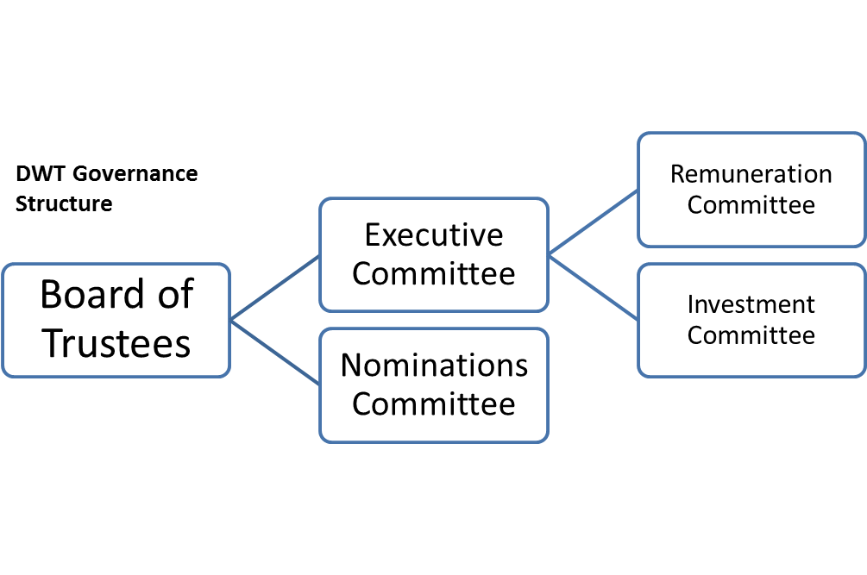
- Lead the development of and agree a strategy that aims to achieve DWT’s charitable purposes
- Ensure that a sound decision-making and monitoring framework is in place
- Manage and monitor organisational performance
- Regularly review the sustainability of DWT’s income sources and business models and their impact on achieving charitable purposes in the short, medium and longer term
- Actively manage risk
- Regularly review key policies
- Regularly review which matters are reserved for the Board and which can be delegated, maintaining a ‘delegations’ framework to make this clear.

An Executive Committee of five trustees (including the Chair of the Board and the Hon Treasurer) is appointed by the Board of Trustees. The Committee’s main roles are to provide oversight of the operational implementation of strategic areas of work, acting as a trustee-level sounding board for the DWT CEO and senior managers, and ensuring strategic and business plans and key policies are implemented in line with Board expectations.

The Board delegates to Executive Committee the following duties:

- Oversight of the performance of the Annual Business Plan and budget once agreed
- Scrutiny of policies and position statements and approval of some as delegated by the Board
- Monitoring Risk Log and ensuring mitigation is effectively implemented
- Monitoring the success of fundraising strategies
- Management of investments and other assets
- Effecting agreed acquisitions and disposals
- Ensuring policies are effectively implemented
- Approving Terms and Conditions of employment, within the budget set by the Board
- Scrutiny of key strategy documents put forward by the CEO and Directors

The Executive Committee is supported in its delegated duties by a Remuneration Committee and Investment Committee. The Board of Trustees delegates trustee and CEO recruitment activities to the Nominations Committee, who make recommendations on appointments for the Board to approve. From time to time, the Board establishes working groups to tackle key issues of interest or concern.

The committee structure described above applies to 2019/20. Following a governance review, DWT Board approved a revised committee structure and revised Terms of Reference for the trading subsidiary boards at the end of this year. The new arrangements come in to effect in May 2020 and will be reported on next year.

The Board delegates the day to day running of the charity to the Chief Executive Officer (CEO), who is supported by a leadership team of Directors.
22

Planning structure:
DWT’s long term goals are set out in its 25 Year Plan. Plans over a five-year period are set out in the Strategic Plan, supplemented by plans for individual programmes and key functions such as income generation. Detailed
plans for each year are set out in the Annual Business Plan. All of the above plans are reviewed periodically, with input from the full team of staff and trustees.

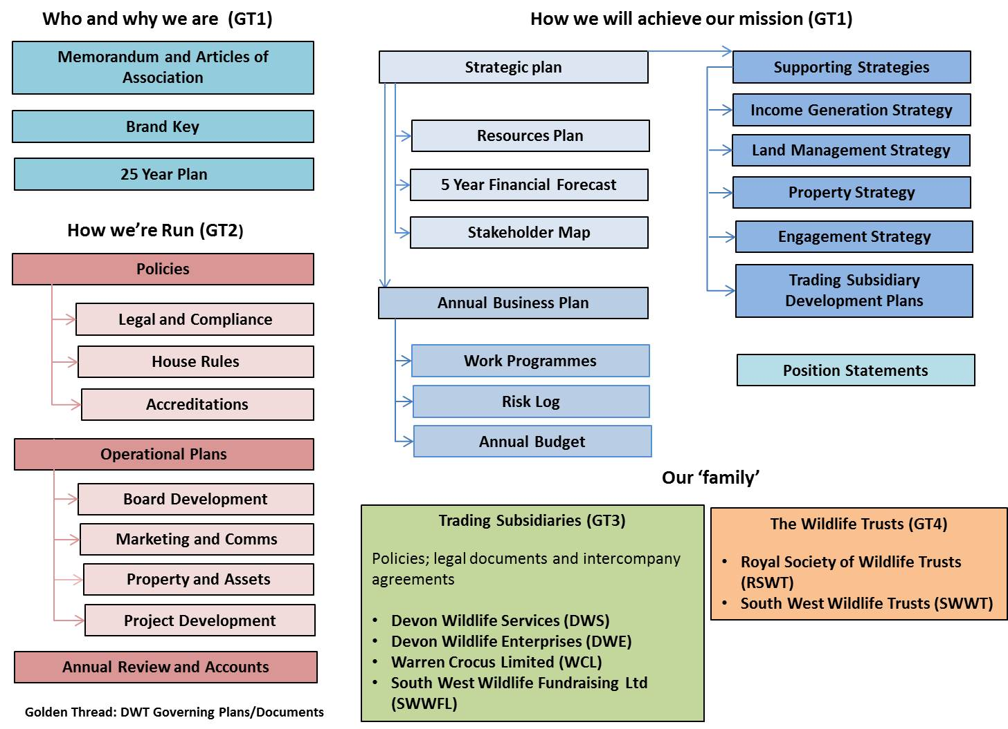

Related parties:
The Devon Wildlife Trust is one of 46 Trusts, which make up The Wildlife Trusts, a national partnership of independent local Trusts active in all aspects of wildlife conservation. DWT is a corporate member of the Royal Society of Wildlife Trusts. On a regional basis, the Trust works collaboratively with the other Wildlife Trusts in the south west, some of whom are partners in the company South West Wildlife Trusts Ltd.

Operational structure:
The work of DWT is divided between three Directorates: Conservation & Development Directorate, Resources & Marketing Directorate and the Commercial & Operations Directorate.
23

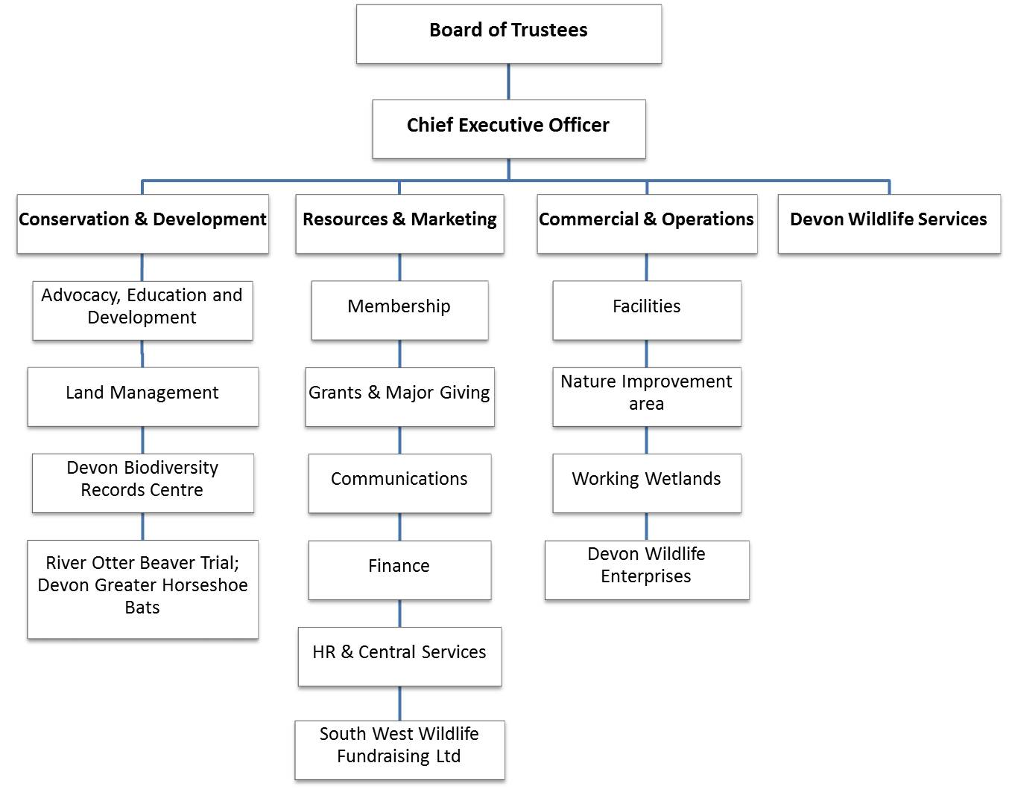
Organisational Structure as of 31/03/20

Seaton Jurassic, which is operated through Devon Wildlife Services, is managed by the DWT Visitor Centre Manager who is line managed by the CEO. The Director of Commercial and Operations line manages the Devon Wildlife Enterprises Manager and the Director of Resources and Marketing is a Director of SWWFL.

At 31 March 2020 the DWT Group had a headcount of 99 staff and a high quality, strongly motivated team. It has Investors in People status (silver award), Investing in Volunteers status and ISO 14001 (environmental performance) accreditation. Around 350 individuals volunteer regularly with the Trust and we are supported by 6 Local Groups and 1 Wildlife Watch group.

Trustee appointment, Induction and Training:
The trustees are elected annually by the members of the charitable company attending the Annual General Meeting. The trustees have the power to appoint new trustees during the year but trustees so appointed must stand for formal election at the next AGM. One third of the trustees retires by rotation each year but may stand for re-election. Collectively the trustees form the Board of DWT and all office holders, including the Chair, are appointed by the trustees. As part of governance improvement, the Board introduced time limits on trustees’ length of service, the norm to be a maximum of two terms of three years. For long standing trustees the requirement to retire is being introduced on a phased basis over three years.

Mike Moser will have served six years as a trustee by the 2020 AGM. Due to his exceptional ecological knowledge, national and international experience and leadership skills, the Board considers that there is a
24

strong and objectively justifiable reason to support extending his length of service from two to three terms of office and have approved this.

As recommended by the Charity Governance Code, trustee appointments are managed by a Nominations Committee. One new trustee, Rebecca Bower, was appointed in 2019 (as reported last year). New trustees participate in a formal induction programme.

In addition to regular business meetings, trustees meet twice annually, once with staff to discuss the strategic development of DWT and once for a trustees only meeting combined with a field trip to encourage trustee cohesiveness.

Board Development:
In 2018 trustees adopted the Charity Governance Code (2017). Following an audit of the Trust against Code principles, a Board Development Plan has been put in place and excellent progress has been made, including a review of committee structures, reporting and agendas. Next steps include improving the trustees’ skills audit, updating the Equality and Diversity Policy and related action plan, and an audit of trading subsidiaries using new Charity Commission guidance

Remuneration arrangements:
Remuneration arrangements at DWT are set out by the Remuneration Committee (comprising of: Honorary Treasurer, Chair of the Board and a trustee appointed by the Board) and authorised by the Board of Trustees. There are eight salary grades, from Chief Executive to Support grade. For each salary grade there is a starting salary and four incremental points, and each member of staff progresses along these scales on an annual basis subject to authorisation from the line manager (or the Chair of the Board of Trustees in the case of the CEO) based on satisfactory performance. Cost of living awards may also be made to all staff if approved by the Board to help keep pace with inflation.

The Remuneration Committee reviews the salary bands periodically and benchmarks them against similar organisations in the region to ensure they are competitive.

The Remuneration Committee meets to make recommendations to the Executive Committee on: -
- Any proposed changes to the salary structure, scales or increments;
- Any annual cost of living increase for staff at DWT;
- Discretionary, one off bonus payments to staff.

There were no discretionary one off bonus payments to senior staff in the financial year.

All trustees give of their time freely and no trustee received remuneration in the year. Details of trustees’ expenses and related party transactions are disclosed in note 9 to the financial statements.

25
Trustees’ Report (incorporating the Directors’ Report for the purposes of s.415 Companies Act 2006)
Year ended 31 March 2020

10 Reference and Administrative Details

The full name of the charity is Devon Wildlife Trust.

Company number: 733321 Charity number: 213224

The members of the Board of Trustees during the year and any offices held or other special responsibilities were:
Miss R M Bower (co-opted 01.07.19, elected 16.11.19, Honorary Treasurer with effect from 04.12.19), Miss R A Broad, Rear Admiral A P Burns OBE, Mrs G D Castle, Mr R J Clack (Honorary Treasurer and Chair of Executive Committee, retired 16.11.19), Mr F V Clarke (retired 16.11.19), Mr A C J Cooper, Mr C E Dixon, Dr S Goodfellow (Chair of the Board of Trustees), Mr G W Hearnden, Mr B P Henwood, Ms G McKenzie, Dr M Moser, Mrs H Nathanson, Prof V D Pope, Mr N W Rendle, Mr T J Smale (retired 16.11.19) and Mr J Whetman.

President: Professor I S Stewart MBE
Secretary: Mr H J Barton
Chief Executive: Mr H J Barton
The Trust’s Principal Advisors were:

Solicitors  Tozers LLP  Broadwalk House  Southernhay West  Exeter  Devon  EX1 1UA | Auditors  PKF Francis Clark  Centenary House  Peninsula Park  Rydon Lane  Exeter  EX2 7XE | Bankers  Lloyds Bank plc  234 High Street  Exeter  Devon  EX4 3NL

Registered Office
Cricklepit Mill
Commercial Road
Exeter
Devon
EX2 4AB

26

Trustees’ Report (incorporating the Directors’ Report for the purposes of s.415 Companies Act 2006)
Year ended 31 March 2020

11 Trustees’ responsibilities in relation to the financial statements

The charity trustees (who are also directors of Devon Wildlife Trust for the purposes of company law) are responsible for preparing a trustees’ annual report and financial statements in accordance with applicable law and United Kingdom Accounting Standards (United Kingdom Generally Accepted Accounting Practice).

Company law requires the charity trustees to prepare financial statements for each year which give a true and fair view of the state of affairs of the charitable company and the group and of the incoming resources and application of resources, including the income and expenditure, of the charitable group for that period. In preparing the financial statements, the trustees are required to:
- select suitable accounting policies and then apply them consistently;
- observe the methods and principles in the Charities SORP;
- make judgements and estimates that are reasonable and prudent;
- state whether applicable UK Accounting Standards have been followed, subject to any material departures disclosed and explained in the financial statements;
- prepare the financial statements on the going concern basis unless it is inappropriate to presume that the charity will continue in business.

The trustees are responsible for keeping proper accounting records that disclose with reasonable accuracy at any time the financial position of the charity and to enable them to ensure that the financial statements comply with the Companies Act 2006. They are also responsible for safeguarding the assets of the charity and the group and hence for taking reasonable steps for the prevention and detection of fraud and other irregularities.

The trustees are responsible for the maintenance and integrity of the corporate and financial information included on the charitable company’s website. Legislation in the United Kingdom governing the preparation and dissemination of financial statements may differ from legislation in other jurisdictions.

12 Statement as to disclosure to our auditors

In so far as the trustees are aware at the time of approving our trustees’ annual report:
- there is no relevant audit information, being information needed by the auditor in connection with preparing their report, of which the charity’s auditor is unaware; and
- the trustees, having made enquiries of fellow directors and the charity’s auditor that they ought to have individually taken, have each taken all steps that they are obliged to take as a director in order to make themselves aware of any relevant audit information and to establish that the auditor is aware of that information.

Trustees’ Report (incorporating the Directors’ Report for the purposes of s.415 Companies Act 2006)
Year ended 31 March 2020

The trustees approve the Trustees’ Annual Report, including approval in their capacity as company directors of the Strategic Report contained within it, on 19 September 2020.

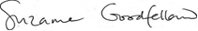
Suzanne Goodfellow  27  Chair of the Board of Trustees | Registered Office  Cricklepit Mill  Commercial Road  Exeter  Devon  EX2 4AB
31
Independent Auditor’s Report to the Members

Year ended 31 March 2020

Opinion
We have audited the financial statements of Devon Wildlife Trust (the “Charity”) for the year ended 31 March 2020 which comprise Group Statement of Financial Activities, Group and Parent Company Balance Sheets, Statement of Consolidated Cash flows and notes to the financial statements, including a summary of significant accounting policies. The financial reporting framework that has been applied in their preparation is applicable law and United Kingdom Accounting Standards (United Kingdom Generally Accepted Accounting Practice), including Financial Reporting Standard 102: The Financial Reporting Standard applicable in the UK and Republic of Ireland.
In our opinion, the financial statements:
- give a true and fair view of the state of the group’s and charity’s affairs as at 31 March 2020 and of its income and expenditure for the year then ended;
- have been properly prepared in accordance with United Kingdom Generally Accepted Accounting Practice;
- have been prepared in accordance with the requirements of the Companies Act 2006.
Basis for opinion
We conducted our audit in accordance with International Standards on Auditing (UK) (ISAs (UK)) and applicable law. Our responsibilities under those standards are further described in the Auditor’s responsibilities for the audit of the financial statements section of our report. We are independent of the Charity in accordance with the ethical requirements that are relevant to our audit of the financial statements in the UK, including the FRC’s Ethical Standard, and we have fulfilled our other ethical responsibilities in accordance with these requirements. We believe that the audit evidence we have obtained is sufficient and appropriate to provide a basis for our opinion.
Conclusions relating to going concern
We have nothing to report in respect of the following matters in relation to which the ISAs (UK) require us to report to you where:
- the trustees’ use of the going concern basis of accounting in the preparation of the financial statements is not appropriate; or
- the trustees have not disclosed in the financial statements any identified material uncertainties that may cast significant doubt about the Charity’s ability to continue to adopt the going concern basis of accounting for a period of at least twelve months from the date when the financial statements are authorised for issue.
Other information
The trustees are responsible for the other information. The other information comprises the information included in the annual report other than the financial statements and our auditor’s report thereon. Our opinion on the financial statements does not cover the other information and, except to the extent otherwise explicitly stated in our report, we do not express any form of assurance conclusion thereon.
28

Independent Auditor’s Report to the Members (continued)

Year ended 31 March 2020

In connection with our audit of the financial statements, our responsibility is to read the other information and, in doing so, consider whether the other information is materially inconsistent with the financial statements or our knowledge obtained in the audit or otherwise appears to be materially misstated. If we identify such material inconsistencies or apparent material misstatements, we are required to determine whether there is a material misstatement in the financial statements or a material misstatement of the other information. If, based on the work we have performed, we conclude that there is a material misstatement of this other information, we are required to report that fact.
We have nothing to report in this regard

Opinions on other matters prescribed by the Companies Act 2006
In our opinion, based on the work undertaken in the course of the audit:
- the information given in the trustees’ report, (which includes the directors’ report prepared for the purposes of company law) for the financial year for which the financial statements are prepared is consistent with the financial statements; and
- the directors’ report included within the trustees’ report have been prepared in accordance with applicable legal requirements.
Matters on which we are required to report by exception
In the light of the knowledge and understanding of the Charity and its environment obtained in the course of the audit, we have not identified material misstatements in the trustees’ report.
We have nothing to report in respect of the following matters in relation to which the Companies Act 2006 requires us to report to you if, in our opinion:
- adequate accounting records have not been kept or returns adequate for our audit have not been received from branches not visited by us; or
- the financial statements are not in agreement with the accounting records and returns; or
- certain disclosures of trustees’ remuneration specified by law are not made; or
we have not obtained all the information and explanations necessary for the purposes of our audit.

Responsibilities of the trustees
As explained more fully in the Statement of Trustees’ Responsibilities set out on page 27, the trustees (who are also the directors of the charity for the purposes of company law) are responsible for the preparation of the financial statements and for being satisfied that they give a true and fair view, and for such internal control as they determine is necessary to enable the preparation of financial statements that are free from material misstatement, whether due to fraud or error.
In preparing the financial statements, the trustees are responsible for assessing the Charity’s ability to continue as a going concern, disclosing, as applicable, matters related to going concern and using the going concern basis of accounting unless the trustees either intend to liquidate the Charity or to cease operations, or have no realistic alternative but to do so.
29

Independent Auditor’s Report to the Members

Year ended 31 March 2020

Our responsibilities for the audit of the financial statements
Our objectives are to obtain reasonable assurance about whether the financial statements as a whole are free from material misstatement, whether due to fraud or error, and to issue an auditor’s report that includes our opinion. Reasonable assurance is a high level of assurance, but is not a guarantee that an audit conducted in accordance with ISAs (UK) will always detect a material misstatement when it exists. Misstatements can arise from fraud or error and are considered material if, individually or in the aggregate, they could reasonably be expected to influence the economic decisions of users taken on the basis of these financial statements.
A further description of our responsibilities for the audit of the financial statements is located on the Financial Reporting Council’s website at: www.frc.org.uk/auditorsresponsibilities. This description forms part of our auditor’s report.
Use of our Report
This report is made solely to the Charity’s members, as a body, in accordance with Chapter 3 of Part 16 of the Companies Act 2006. Our audit work has been undertaken so that we might state to the Charity’s members those matters we are required to state to them in an auditor’s report and for no other purpose. To the fullest extent permitted by law, we do not accept or assume responsibility to anyone other than the Charity’s members as a body, for our audit work, for this report, or for the opinions we have formed.

STEPHANIE HENSHAW (Senior Statutory Auditor)
For and on behalf of
PKF FRANCIS CLARK
Chartered Accountants & Statutory Auditor
Centenary House
Peninsula Park
Rydon Lane
Exeter
EX2 7XE

XXX 2020
30
Group Statement of Financial Activities (including Income & Expenditure Account)
For the year ended 31 March 2020
 | Note |  | Unrestricted |  | Restricted |  | Endowment |  | Total |  | Total
 |  |  | Funds |  | Funds |  | Funds |  | Year ended |  | year ended
 |  |  |  |  |  |  |  |  | 31 March |  | 31 March
 |  |  |  |  |  |  |  |  | 2020 |  | 2019
 |  |  | £ |  | £ |  | £ |  | £ |  | £
Income
Donations and legacies | 2 |  | 1,873,288 |  | 280,415 |  | - |  | 2,153,703 |  | 2,829,353
Charitable activities | 3 |  | 1,000,908 |  | 1,946,552 |  | - |  | 2,947,460 |  | 2,084,136
Other trading activities
Commercial trading operations | 4 |  | 286,619 |  | - |  | - |  | 286,619 |  | 301,668
Investment income | 5 |  | 7,174 |  | 1,841 |  | 3,846 |  | 12,861 |  | 15,502
Other income | 6 |  | 4,527 |  | 1,734 |  | - |  | 6,261 |  | 5,528
Total income |  |  | 3,172,516 |  | 2,230,542 |  | 3,846 |  | 5,406,904 |  | 5,236,187
Expenditure
Costs of raising funds
Fundraising and membership | 7a |  | 430,232 |  | - |  | 1,640 |  | 431,872 |  | 449,977
Commercial trading operations | 4 |  | 362,789 |  | - |  | - |  | 362,789 |  | 445,391
Charitable activites | 7b |  | 2,136,263 |  | 1,432,174 |  | 6,293 |  | 3,574,730 |  | 3,273,416
Total expenditure |  |  | 2,929,284 |  | 1,432,174 |  | 7,933 |  | 4,369,391 |  | 4,168,784
Net (losses) / gains on investments |  |  | - |  | - |  | (4,693) |  | (4,693) |  | (384)
Net income/(expenditure) for the year before transfers |  |  | 243,232 |  | 798,368 |  | (8,780) |  | 1,032,820 |  | 1,067,019
Transfers between funds |  |  | 104,735 |  | - |  | (104,735) |  | - |  | -
 |  |  | 347,967 |  | 798,368 |  | (113,515) |  | 1,032,820 |  | 1,067,019
Other recognised gains / (losses)
Gains / (losses) on revaluation of investments |  |  | (18,079) |  | - |  | (1,658) |  | (19,737) |  | 489
Net movement in funds |  |  | 329,888 |  | 798,368 |  | (115,173) |  | 1,013,083 |  | 1,067,508
Fund balances brought forward |  |  | 4,449,215 |  | 2,394,623 |  | 1,362,075 |  | 8,205,913 |  | 7,138,405
Total funds carried forward |  |  | 4,779,103 |  | 3,192,991 |  | 1,246,902 |  | 9,218,996 |  | 8,205,913

31
Balance Sheets
At 31 March 2020
 |  | Group |  |  |  | Charity
 |  | 2020 |  | 2019 |  | 2020 |  | 2019
 | Note | £ |  | £ |  | £ |  | £
Fixed assets
Tangible fixed assets | 11 | 2,229,780 |  | 2,277,301 |  | 2,225,829 |  | 2,273,350
Heritage assets | 12 | 3,746,978 |  | 3,672,052 |  | 3,746,978 |  | 3,672,052
Investments | 13 | 260,502 |  | 238,329 |  | 260,802 |  | 238,629
 |  | 6,237,260 |  | 6,187,682 |  | 6,233,609 |  | 6,184,031
Current assets
Stocks |  | 18,161 |  | 13,289 |  | - |  | -
Debtors | 14 | 889,124 |  | 1,685,667 |  | 1,021,284 |  | 1,978,160
Cash at bank and in hand |  | 2,546,262 |  | 1,539,214 |  | 2,504,902 |  | 1,468,548
 |  | 3,453,547 |  | 3,238,170 |  | 3,526,186 |  | 3,446,708
Creditors: amounts falling due
within one year | 15 | (471,811) |  | (1,219,939) |  | (443,087) |  | (1,172,043)
Net current assets |  | 2,981,736 |  | 2,018,231 |  | 3,083,099 |  | 2,274,665
Net assets |  | 9,218,996 |  | 8,205,913 |  | 9,316,708 |  | 8,458,696
Endowment funds | 16 | 1,246,902 |  | 1,362,075 |  | 1,246,902 |  | 1,362,075
Restricted funds | 18 | 3,192,991 |  | 2,394,623 |  | 3,192,991 |  | 2,394,623
Unrestricted funds:
- Designated | 20 | 990,161 |  | 1,000,000 |  | 990,161 |  | 1,000,000
- Free reserves | 20 | 1,000,000 |  | 829,665 |  | 1,101,363 |  | 1,086,399
- Fixed asset reserves | 20 | 2,788,942 |  | 2,619,550 |  | 2,785,291 |  | 2,615,599
Total funds | 22 | 9,218,996 |  | 8,205,913 |  | 9,316,708 |  | 8,458,696

These financial statements have been approved for issue by the Trustees on 19 September 2020.
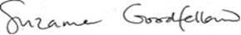

Suzanne Goodfellow

Registered company number 733321

32
Statement of Consolidated Cash Flows
For the year ended 31 March 2020
 |  | 2020 |  | 2019
 | Note | £ |  | £
Cash provided by operating activities | 26 | 1,230,480 |  | 1,231,644
Cash flows from investing activities
Dividends, interest and income from investments |  | 12,861 |  | 15,502
Purchase of tangible fixed assets |  | (187,926) |  | (98,123)
Proceeds on disposal of tangible fixed assets |  | 278 |  | 1,874
Purchase of investments |  | (148,809)
Proceeds on disposal of investments |  | 100,164 |  | -
Cash used in investing activities |  | (223,432) |  | (80,747)
Increase in cash and cash
equivalents in the year |  | 1,007,048 |  | 1,150,897
Cash and cash equivalents at the beginning
of the year |  | 1,539,214 |  | 388,317
Cash and cash equivalents at the end of
the year |  | 2,546,262 |  | 1,539,214

The notes on pages 34 to 56 form an integral part of the financial statements.
33

Notes to the group accounts
Year ended 31 March 2020

1 Accounting Policies

(a) Basis of accounting
The financial statements have been prepared in accordance with Accounting and Reporting by Charities: Statement of Recommended Practice applicable to charities preparing their accounts in accordance with the Financial Reporting Standard applicable in the UK and Republic of Ireland" (FRS 102 (effective 1 January 2015) - Charities SORP (FRS 102), the Financial Reporting Standard applicable in the UK and Republic of Ireland (FRS 102) and the Companies Act 2006.

Devon Wildlife Trust meets the definition of a public benefit entity under FRS 102. Assets and liabilities are initially recognised at historical cost or transaction value unless otherwise stated in the relevant accounting policy note.

The basis of the trustees assessment relating to the assessment of going concern is explained in the Trustees Report under “Covid-19”.

The charity meets the definition of a qualifying entity under FRS102 and has therefore taken advantage of disclosure exemptions available to it. Exemptions have been taken in relation to company financial instruments and the company cash flow statement.

The presentational currency of Devon Wildlife Trust is considered to be pounds sterling because it is the currency of the primary economic environment in which the charitable company operates.

(b) Company status
The charity is a company limited by guarantee. The charity was incorporated in England and Wales and details of the registered office can be found in the reference and administration section of the Trustees’ Report.

The members of the company are the subscription paying members of the Trust. In the event of the charity being wound up, the liability in respect of the guarantee is limited to £1 per member of the charity.

(c) Incoming resources
The incoming resources are included in the SOFA when the Trust is legally entitled to the income and the amount can be quantified with reasonable accuracy. No amounts are included in the financial statements for services donated by volunteers. Specific policies for individual income sources are set out below. All income is accounted for gross except for occasional instances relating to small fundraising events.

Voluntary income
Membership subscriptions, donations and other forms of voluntary income are credited to income when receivable. Any restrictions which require income to be spread over more than one accounting period are reflected in the accounts as deferred income. Membership income includes amounts paid by members with their subscriptions but in excess of the standard subscription rates.

Life membership
Subscriptions for life memberships are deemed to continue, on average, for 25 years. Life membership subscriptions are therefore credited to income in 25 equal annual instalments. The balance of these subscriptions which has not been credited to income at the year end is included in creditors as deferred income.

34
Notes to the group accounts (continued)
Year ended 31 March 2020

Legacies
A legacy is recognised in the year as income when it is probable that it will be received. Bequests of tangible assets are recorded at probate value or the best alternative available estimate of market value. Any restrictions which require income to be spread over more than one accounting period are reflected in the accounts as deferred income.

Grants receivable
Grants receivable for general purposes are included in income in the year in which they are receivable. Grants are not recognised as receivable until any conditions for receipt have been complied with. Where donor-imposed restrictions apply to the timing of the related expenditure as a pre-condition for its use the grant is treated as deferred income until those restrictions are met. Grants for specific purposes are accounted for as restricted funds until they are fully expended. Grants received for the purchase of fixed assets are credited to income in full in the year of receipt.

(d) Resources expended
All expenditure is accounted for on an accruals basis and has been classified under headings which aggregate all costs related to each category. Costs in each category include all costs specifically incurred in respect of those activities as well as the attributable proportion of general management and administration expenses. These expenses are allocated broadly on the following bases:

Property costs, materials, health & safety and IT - staff numbers and the proportion of the HQ building
occupied by them
Motor and travel expenses - actual mileage recorded
Postage, printing and stationery - actual usage
Indirect salaries, telephone, professional fees etc. - in the same proportions as the totals of the allocation
above
Non-recoverable VAT is charged according to the amount of VAT cost which has been incurred together with any amounts apportioned as outlined above.

(e) Fund accounting
Unrestricted funds are available for use at the discretion of the Trustees in the furtherance of the general objectives of the Trust. Restricted funds are funds which are to be applied in accordance with specific restrictions imposed by donors or which have been raised by the Trust for particular purposes. The costs of raising and administering such funds are charged against the specific fund to the extent that restrictions on the income permit. The aims and uses of the significant closing restricted funds are set out in note 18 to the accounts.

Designated funds are those funds transferred by the Trustees from unrestricted funds for particular purposes or projects.

The Permanent Endowment Fund represents those assets which must be held permanently by the charity. Incoming resources from assets held as endowment investments form part of unrestricted funds.

(f) Tangible fixed assets and depreciation
All tangible fixed assets are capitalised and are included at cost including any incidental costs of acquisition. Depreciation is calculated to write off the cost of fixed assets less their estimated residual value over their expected useful lives at the rates and on the bases shown below:

Freehold property - 2% of cost
Motor vehicles - 25% of reducing balance
Computer equipment - 33.3 % of cost
Improvements to property - 2 to 20% of cost
Other equipment - 25% of cost
Freehold land is not depreciated.
35
Notes to the group accounts (continued)
Year ended 31 March 2020

(g) Heritage assets
Heritage assets represent the cost of the charity’s nature reserves at the date of acquisition, which are held in pursuit of its conservation objectives.

(h) Investments
Investments are stated at market value at the balance sheet date. The SOFA includes the net gains and losses arising on revaluations and disposals throughout the year. Investments in subsidiaries are stated at cost.

(i) Stocks
Stocks are stated at the lower of cost or net realisable value. Net realisable value represents the sales price less the direct costs of selling.

(j) Leased assets
Where assets are financed by leasing agreements (‘finance leases’) the assets are included in the balance sheet at cost less depreciation in accordance with normal accounting policies. The future rental payments are shown as a liability. Interest is charged to the SOFA over the period of the lease in proportion to the balance of the capital outstanding. Rentals payable under operating leases are charged to the profit and loss account as incurred.

(k) Group financial statements
The financial statements consolidate the results of the charity and its subsidiary undertakings on a line-by- line basis. A separate Statement of Financial Activities and Income and Expenditure Account for the charity has not been presented because the charity has taken advantage of the exemption afforded by section 408 Companies Act 2006.

(l) Pension costs

Defined contribution scheme

The Trust makes defined contribution payments to pension schemes for the benefit of employees who wish to participate. All schemes are personal pensions to which the Trust makes employer’s contributions. The assets of the schemes are administered by pension scheme trustees in funds entirely independent from those of the Trust.

Defined benefit scheme
The Trust participates in the Devon County Council Pension Fund, which is a defined benefit pension fund, in respect of one employee who transferred from Exeter City Council under a TUPE agreement in 2019. Under the terms of the transfer agreement, the Trust is only responsible for specified annual contributions of £6,000 p.a, with all other obligations guaranteed or underwritten by Exeter City Council. The substance of the arrangement between the parties is therefore that of a defined contribution scheme and therefore these financial statements reflect only the contributions payable in respect of the current year. This is a deparature from the requirements of FRS 102 to present the pension obligation and related reimbursement right as separate liability and asset . In the opinion of the trustees, to reflect the liability and related asset separately and recognise all the related movements in the Statement of Financial Activities would result in a degree of complexity and detail which is out of proportion to the significance of the arrangement to the charity. At the date of admission the actuarial valuation of the scheme was a deficit of £126,000. At 31 March 2020 the actuarial valuation was a deficit of £104,000.

(m) Corporation tax
The charity is exempt from tax on income and gains falling within section 505 of the Taxes Act 1988 or section 252 of the Taxation of Chargeable Gains Act 1992 to the extent that these are applied to its charitable objects.
36
(n) Critical accounting judgements and key areas of estimation uncertainty
In the application of the company’s accounting policies, which are described above, the directors are required to make judgements, estimates and assumptions about the carrying amounts of assets and liabilities that are not readily apparent from other sources. The estimates and associated assumptions are based on historical experience and other factors that are considered to be relevant. Actual results may differ from these estimates.

The estimates and underlying assumptions are reviewed on an ongoing basis. Revisions to accounting estimates are recognised in the period in which the estimate is revised if the revision affects only that period, or in the period of the revision and future periods if the revision affects both current and future periods.

The trustees do not consider there to be any critical judgements or estimates.

(o) Financial Instruments
Financial assets and financial liabilities are recognised in the group’s balance sheet when the group becomes party to the contractual provisions of the instrument.
- Financial assets, which comprise, trade and other debtors and cash at bank balances, are initially measured at transaction price (including transaction costs) and are subsequently measured at the undiscounted amount receivable. Fixed asset investments qualifying as basic financial instruments are measured at fair value through income and expenditure.
- Financial liabilities which comprise trade and other creditors are initially measured at transaction price (including transaction costs) and are subsequently measured at the undiscounted amount payable. Long term financial liabilities which comprise redeemable preference shares and other borrowings are measured at amortised cost.
37
Notes to the group accounts (continued)
Year ended 31 March 2020

2 Income from donations and legacies
Unrestricted Restricted Total Funds
Funds Funds 2020 2019
£ £ £ £
Subscriptions and related donations 1,230,025 - 1,230,025 1,148,895
Gifts and donations 88,678 273,745 362,423 183,081
Charitable trusts 13,000 - 13,000 -
Local group income 3,019 - 3,019 6,235
Legacies 537,090 6,670 543,760 1,454,859
Corporate donations 1,476 - 1,476 36,283
–––--–––– ––––––– ––––--––– –––--––––
1,873,288 280,415 2,153,703 2,829,353
========= ======= ========= =========

Income from donations and legacies of £2,153,703 (2019: £2,829,353) comprises unrestricted income of £1,873,288 (2019: £2,747,586) and restricted income of £280,415 (2019: £81,767).

3 Income from charitable activities
Unrestricted Restricted Total Funds
Funds Funds 2020 2019
£ £ £ £
Grants 74,418 834,593 909,011 742,085
Lottery - 463,824 463,824 260,546
Charitable trusts - 212,204 212,204 136,295
Landfill tax credits - 2,045 2,045 83,592
Commercial income 926,490 433,886 1,360,376 861,618
–--–––––– ––--––––– –––--–––– ––--–––––
1,000,908 1,946,552 2,947,460 2,084,136
========= ========= ========= =========

Income from charitable activities of £2,947,460 (2019: £2,084,136) comprises unrestricted income £1,000,908 (2019: £869,952) and restricted income of £1,946,552 (2019: £1,214,184).
38

Notes to the group accounts (continued)
Year ended 31 March 2020

4 Commercial trading operations

2020 2019
Turnover £ £ Ecological consultancy & advisory (Devon Wildlife Enterprises Ltd) 209,797 180,733
Seaton Jurassic (Devon Wildlife Services Ltd) 76,822 120,935
––––––– –––––––
286,619 301,668
======= =======

Expenses £ £ Ecological consultancy & advisory (Devon Wildlife Enterprises Ltd) 178,662 150,818
Seaton Jurassic (Devon Wildlife Services Ltd) 184,127 294,573
––––––– –––––––
362,789 445,391
======= =======

Devon Wildlife Enterprises Ltd and Devon Wildlife Services are wholly owned subsidiaries of the charity,
and full details of their results are set out in Note 25.

All income and expenditure from trading operations is unrestricted.

5 Investment income
Unrestricted Restricted Total Funds
Funds Funds 2020 2019
£ £ £ £
Bank, building society and other interest 7,174 5,687 12,861 15,490
Fixed asset investment income - - - 12
––––––– ––––––– ––––––– –––––––
7,174 5,687 12,861 15,502
======= ======= ======= =======

Income from investments of £12,861 (2019: £15,502) comprises unrestricted income £7,174 (2019: £7,082) and restricted income of £5,687 (2019: £8,420).

6 Other income
Unrestricted Restricted Total Funds
Funds Funds 2020 2019
£ £ £ £
Profit / (loss) on disposal of tangible fixed assets 2,853 - 2,853 (317)
Insurance claim - 734 734 5,845
Other Income 1,674 1,000 2,674 -
––––––– ––––––– ––––––– –––––––
4,527 1,734 6,261 5,528
======= ======= ======= =======

Other income of £6,261 (2019: £5,528) comprises unrestricted income £4,527 (2019: £4,794) and restricted income of £1,734 (2019: £734).
39
Notes to the group accounts (continued)
Year ended 31 March 2020

7 (a) Costs of raising voluntary income – fundraising and membership
2020 2019
£ £
Personnel costs 366,842 394,973
Materials and equipment 11,811 10,235
Vehicle and travel expenses 1,704 2,157
Property expenses 2,724 16,540
Office expenses 26,872 20,917
Depreciation 1,654 2,248
Other costs 20,265 2,907
–-––––– –––––––
431,872 449,977
======= =======
Costs of raising voluntary income of £431,872 (2019: £449,977) comprises unrestricted £430,232 (2019: £448,156) and endowment £1,640 (2019: £1,821).

(b) Costs of charitable activities
Charitable Support Total Total
activities costs 2020 2019
£ £ £ £
Personnel costs 2,588,213 101,503 2,689,716 2,389,482
Materials and equipment 121,710 7,681 129,391 126,726
Vehicle and travel expenses 104,079 6,491 110,570 114,765
Property expenses 131,836 14,528 146,364 132,286
Office expenses 237,395 15,056 252,451 231,207
Depreciation 150,568 8,822 159,390 178,050
Non-recoverable VAT - - - 1,021
Other costs 51,478 162 51,640 65,569
Governance costs 27,100 8,098 35,208 34,310
–––––––– ––––––– –––––––– ––––––––
3,412,389 162,341 3,574,730 3,273,416
======== ======= ======== ========
Expenditure on charitable activities of £3,574,730 (2019: £3,273,416) comprises unrestricted £2,136,263 (2019: £1,978,111), restricted £1,432,174 (2019: £1,288,470) and endowment £6,293 (2019: £6,835).

(c) Governance costs
2020 2019
£ £
Personnel costs 25,323 25,605
Materials and equipment 978 178
Vehicle and travel expenses 692 288
Office expenses 8,215 8,212
Legal and professional - -
Other costs - 27
–––––– –––––––
35,208 34,310
====== =======
40
Notes to the group accounts (continued)
Year ended 31 March 2020

8 Total resources used – other information 2020 2019
£ £
- Total expenditure includes:

Auditor’s fees for the audit of these accounts 14,750 14,250
Auditor’s fees – other services 4,910 7,377
Operating lease expense 84,437 56,379
======= =======
- Personnel costs

Wages and salaries 2,203,220 2,006,914
Social security costs 189,262 168,260
Other pension costs 107,520 97,283
Recruitment 6,093 6,137
––--––––– ––––--–––
Total staff costs 2,506,095 2,278,594

Contractors and consultants 698,058 702,458
Training and development 24,484 12,863
Volunteer costs 12,235 20,742
––––--––– –––––--––
3,240,872 3,014,657
========= =========

Pension contributions for the year not yet remitted to pension providers by the end of the year amounted to £12,850 (2019: £10,562). During the year one employee received emoluments of greater than £60,000 (2019: one), falling within the band £70,000 to £80,000 (2019: £70,000 to £80,000).

(c) The total number of employees, by function, was:
2020 2019

Land Management 11 10
Landscape Scale Conservation & Projects 20 17
Conservation Advocacy 3 4
Education 4 4
Devon Biodiversity Records Centre (DBRC) 6 5
DWE (Ecological Consultancy) 5 4
DWS (Seaton) 4 8
Fundraising 4 3
Membership 3 3
Resources 9 8
Directorate 4 4
Communications 4 3
Finance 4 3
–––––– ––––––
81 76
======= =======

The key management personnel of the parent charity comprise the trustees and the senior leadership team. The total employee benefits of the key management personnel of the charity were £235,448 (2019: £226,277).
41
Notes to the group accounts (continued)
Year ended 31 March 2020

9 Transactions with trustees and connected parties
Trustees received no remuneration in the year (2019: £nil).

One trustee was reimbursed for expenses during the year totalling £172 (2019: £nil). A total of £27,569 including VAT (2019: £48,591) was paid to Tozers Solicitors, a firm in which one Trustee, Mr F V Clarke, is a partner.

A close family member of a trustee was remunerated £20,017 (2019: £13,701) during the year.

There were no other related party transactions.

10 Trustees’ indemnity insurance

Devon Wildlife Trust has purchased insurance to protect the group from loss arising from the defaults of its Trustees, employees or agents. The insurance covers the Trustees and Directors of the Trust and its subsidiary companies. The premium for the year was £212 including premium tax (2019: £455).

42

Notes to the group accounts (continued)
Year ended 31 March 2020

11 Tangible fixed assets Freehold Improve- Equipment,
(a) Group land & ments to fixtures & Motor
property property fittings Vehicles Total
Cost £ £ £ £ £
Balance at 1 April 2019 2,207,241 1,409,708 1,148,869 348,661 5,114,479
Additions - 64,142 41,048 7,810 113,000
Disposals - - - (2,380) (2,380)
–––––––– –––––––– –––––––– ––––––– ––––––––
Balance 2,207,241 1,473,850 1,189,917 354,091 5,225,099
–––––––– –––––––– –––––––– ––––––– ––––––––
Accumulated depreciation
Balance at 1 April 2019 539,992 959,031 1,070,177 267,978 2,837,178
Charge for the year 42,286 52,180 47,285 18,492 160,243
Disposals - - - (2,102) (2,102)
–––––--–– ––––––– ––––––-– ––––––– ––--–––––
Balance at 31 March 2020 582,278 1,011,211 1,117,462 284,368 2,995,319 –––--–––– ––––––– -- –––-–––– ––––-––– –––--––––
Net book value at 31 March 2020 1,624,963 462,639 72,455 69,723 2,229,780
========= ======= ======= ======= =========
Net book value at 31 March 2019 1,667,249 450,677 78,692 80,683 2,277,301
========= ======= ======= ======= =========

(b) Charity Freehold Improve- Equipment,
land & ments to fixtures & Motor
property property fittings Vehicles Total
Cost £ £ £ £ £
Balance at 1 April 2019 2,203,290 1,409,708 1,137,216 348,661 5,098,875
Additions - 64,142 41,048 7,810 113,000
Disposals - - - (2,380) (2,380)
–--–––––– ––––--––– ––-––––– ––––––– ––––--–––
Balance at 31 March 2020 2,203,290 1,473,850 1,178,264 354,091 5,209,495
–––––--–– –––--–––– –––-–––– ––––––– –––--––––
Accumulated depreciation
Balance at 1 April 2019 539,992 959,031 1,058,524 267,978 2,825,525
Charge for the year 42,286 52,180 47,285 18,492 160,243
Disposals - - - (2,102) (2,102)
––––--––– ––––-––– –––––--–– ––––––– ––––––--–
Balance at 31 March 2020 582,278 1,011,211 1,105,809 284,368 2,983,666
–––--–––– –––-–––– –––––-–– ––––––– ––--–––––

Net book value at 31 March 2020 1,621,012 462,639 72,455 69,723 2,225,829
========= ======= ======= ======= =========
Net book value at 31 March 2019 1,663,298 450,677 78,692 80,683 2,273,350
========= ======= ======= ======= =========
43

Notes to the group accounts (continued)
Year ended 31 March 2020

12 Heritage assets
Group and Charity
£
Cost at 1 April 2019 3,672,052 Additions 74,926
––––--–––
Cost at 31 March 2020 3,746,978 =========
Heritage assets comprise nature reserves and property. Transactions over the previous six years may be
summarised as follows:
£
Cost at 1 April 2012 2,007,303 Additions at cost - 2013 1,110,868
- 2014 229,044
- 2015 60,934
- 2016 215,179
- 2017 48,724
- 2018 -
- 2019 -
- 2020 74,926
–--––––––
Cost at 31 March 2020 3,746,978 =========

13 Fixed asset investments

Investment in subsidiary undertakings
 |  |  | Charity
 |  | Subsidiary Undertakings | Total
 |  | £ | £
Cost
Balance at 1 April 2019 |  | 25,300 | 25,300
 |  | ––––––– | –––––––
Balance at 31 March 2020 |  | 25,300 | 25,300
 |  | ––––––– | –––––––
Impairment
Balance at 1 April 2019 |  | 25,000 | 25,000
 |  | ––––––– | –––––––
Balance at 31 March 2020 |  | 25,000 | 25,000
 |  | ––––––– | –––––––
Net book value at 31 March 2020 |  | 300 | 300
 |  | ======== | ========
Net book value at 31 March 2019 |  | 300 | 300
 |  | ======== | ========
44
Notes to the group accounts (continued)
Year ended 31 March 2020

Fixed asset investments (continued)

Listed investments
Group and Charity
2020 2019
£ £
Market value at 1 April 238,329 240,045
Additions 148,809 6,505
Disposals (100,164) (18,518)
Realised (loss) / gain on investments (4,693) (384) Unrealised (loss) / gain on investments (19,737) 489
Movement in cash holdings (2,042) 10,234
Accrued interest - (42) ––––––– –––––––
Market value at 31 March 260,502 238,329
======= =======
Historical cost at 31 March 226,053 159,882
======= =======

The closing carrying value of fixed asset investments is analysed
between different asset types as follows:
2020 2019
£ £
Investment and unit trusts: UK - market value 260,502 238,329
Investments in subsidiary undertakings – cost 300 300
–-––––– –––––––
Net book value of the charity’s investments at 31 March 260,802 238,629 ======= ======= See note 25 for further details of the subsidiary undertakings.

14 Debtors Group Charity
2020 2019 2020 2019
£ £ £ £
Trade debtors 439,263 1,148,974 387,166 1,091,617 Amounts owed by subsidiary undertakings - - 192,990 352,284
Other debtors and prepayments 449,861 536,693 411,128 534,259 ––––––– –––––––– ––––-––– –––––––
889,124 1,685,667 1,021,284 1,978,160 ======= ========= ======== =======
Trade debtors principally represent amounts due from third parties in respect of services provided by the Charity, together with grants and gift aid receivable.

Amounts owed by subsidiary undertakings include £118,674 (2019: £210,000) which is due after more than one year.
45
Notes to the group accounts (continued)
Year ended 31 March 2020

15 Creditors – amounts falling due
within one year Group Charity
2020 2019 2020 2019
£ £ £ £
Trade creditors 111,487 188,747 103,422 182,081
Income received in advance 124,308 635,459 124,308 635,459
Other creditors and accruals 236,016 395,733 215,537 354,503
––-–––– ––-––––– ––-––––– –-–-–––––
471,811 1,219,939 443,087 1,172,043 ======= ======== ======== =========
Income received in advance (deferred income) comprises grant income which relates to the
following financial year.
£
Balance at 1 April 2019 635,459
Amount released to income earned from charitable activities (646,658)
Amount deferred in year 135,507
–––––––
Balance at 31 March 2020 124,308
========
16 Endowment Funds – Group and Charity

Balance at Income Balance at
1 April 2019 and losses Expenditure Transfers 31 March 2020
£ £ £ £ £
Permanent
Hawkswood 56,399 240 - - 56,639
Bank Commander & Cutting machine 1,078 - (1,078) - -
Woodah Farm 597,000 - (4,600) - 592,400
Expendable
Marsland 707,598 (2,745) (2,255) (104,735) 597,863
–--–––––– ––––––– ––––––– –––––-–– ––-–––––
1,362,075 (2,505) (7,933) (104,735) 1,246,902
========= ======== ======== ======== ========

Hawkswood and Marsland represent legacies to the Charity for the ongoing maintenance of particular reserves. Any income arising from the funds must be applied towards the work on nature reserves each year. Expendable endowment permits the underlying capital to be applied for the benefit of the reserve.

17 Endowment Funds prior year comparative – Group and Charity
Balance at Income Balance at
1 April 2018 and gains Expenditure Transfers 31 March 2019
£ £ £ £ £
Permanent
Hawkswood 56,532 (133) - - 56,399
Bank Commander & Cutting machine 2,698 - (1,620) - 1,078
Woodah Farm 601,600 - (4,600) - 597,000
Expendable
Marsland 709,796 238 (2,436) - 707,598
–––––--–– ––––––– ––––––– ––––––– ––--–––––
1,370,626 105 (8,656) - 1,362,075
========= ======= ======= ======== =========
46
Notes to the group accounts (continued)
Year ended 31 March 2020

18. Restricted Funds – Group and Charity
Balance at Balance at
1 April 2019 Income Expenditure Transfers 31 March 2020
£ £ £ £ £
Advocacy and Development 7,561 378,631 (74,295) 3,674 315,571
Active Neighbourhoods 26 - - (26) -
Andrews Wood 55,855 - - - 55,855
Bellever Moor and Meadows 1,500 - - - 1,500
Bellever Suez Communities Trust 612 - (294) - 318
Bystock 207,632 - - - 207,632
Capital - Vehicles 18,028 - (11,429) - 6,599
Cricklepit – Hydro Turbine 43,752 - (4,376) - 39,376
Communications - 59,233 (26,394) - 32,839
Dartmoor Reserves – Capital 12,185 - (2,838) - 9,347
Devon Biodiversity Record Centre - 28,169 - - 28,169
Education and Engagement 3,154 122,219 (106,222) - 19,151
Education and Engagement - Capital 4,986 - (2,109) - 2,877
Greater Horseshoe Bat Project 13,982 221,544 (228,690) - 6,836
GHBP Bat Game 3,071 - (3,071) - -
GHBP Bat Appeal 5,000 - - - 5,000 Horsey Island - 25,005 (20,005) - 5,000
Lower East Lounston - 74,150 - - 74,150
Headon Farm - GrantScape 53,125 - - - 53,125 Headon Farm –
Viridor Credits 220,000 - - - 220,000
Holwell 356,506 - - - 356,506
Land Management 45,403 340,946 (320,113) 3,142 69,378
Magnificent Mires - Capital 8,235 - (3,733) - 4,502 Marsland Fund 194,478 - (1,246) - 193,232
Marsland Land Rover 4,831 - (1,079) - 3,752
Meeth Quarry - Viridor Credits 673,765 - - - 673,765
Meeth Quarry – Natural England 54,004 - (10,463) - 43,541
Meeth Quarry – DWM 8,432 - (8,292) - 140
Neadon Trust & Grants and Major Giving 3,648 4,000 - (3,648) 4,000
New England Wood -
Viridor Credits 41,000 - - - 41,000
NDNIA 23,050 399,396 (381,138) - 41,308
Other Restricted Grants 14,795 - (14,795) - - ROBT Capital 4,038 1,200 (3,463) - 1,775
ROBT Revenue 2,747 90,793 (88,950) - 4,590
Valley Parks - 452,247 (73,209) - 379,038
Volunteering 191 - - - 191
Visitor Assets 3,000 8,718 (4,630) - 7,088
Wild Futures - Capital 517 - (116) - 401
Wild Paths - Revenue 3,142 20,641 (20,641) (3,142) -
Woodah Farm – Taylor Memorial Trust 170,086 - (12,270) - 157,816
Woodah – Phoebe Wortley – Talbot
Charitable Trust 120,826 - (5,020) - 115,806
Working Wetlands - Capital 5,561 3,650 (1,976) - 7,235
Working Wetlands – Biffa Award 5,899 - (1,317) - 4,582
–--–––––– –––––----- ––––----–– ––––––– –--––––––
2,394,623 2,230,542 (1,432,174) - 3,192,991 ========= ========= ========= ======= =========
47

Notes to the group accounts (continued)
Year ended 31 March 2020

18 Restricted Funds: Revenue – Group and Charity
48
Fund | Fund Description
Advocacy and Development | Funds to support conservation initiatives including: Catchment Partnerships in East and North Devon (Environment Agency and Westcountry Rivers Trust); health and wellbeing projects with Active Devon, EDP Drug & Alcohol Services, and the Local Nature Partnership (Sport England), and Ottery St Mary Natural Flood Management work supported by the Environment Agency and Devon County Council. Soils and Water Video is included to which depreciation is applied.
 | Caen Wetlands - Funding in advance from Esmée Fairbairn Foundation (mostly carried forward to 2020/21) for feasibility work into a ‘green finance’ scheme for a wetland site adjacent to Horsey Island that DWT purchased this year.
 | Conservation Communities: Initial funding in advance from NLHF for a new project to bring people together to discover and protect wildlife in eleven adjoining parishes along the banks of Devon’s River Torridge.
 | Saving Devon’s Treescapes: Initial funding in advance from NLHF for development phase of a new project to address Ash Dieback disease across Devon (most of this income was carried forward to 2020/21.
Active Neighbourhoods | Project in partnership with and funded by – Plymouth City Council
Andrew’s Wood | Relates to the purchase of Wizaller Wood, an extension to Andrew’s Wood NR, part funded by the NLHF.
Bellever Moor and Meadows | Relates to provision for the replacement of a bench on the site.
Bellever Suez Communities Trust | Illustrated Log Bench at Bellever Moor and Meadows reserve.
Bystock | Relates to the purchase of the lease of Bystock nature reserve thanks to an appeal, major donor and community support.
Capital - Vehicles | Tractors and quad bikes purchased with income from restricted capital grants
Cricklepit - Hydro Turbine | Installed at Cricklepit Mill in 2010, supported by a range of funders.
Communications | Funding from Strategic Development Fund at RSWT for the Action for Insects campaign.
Dartmoor Reserves – Capital | Relating to work to improve habitat and public access on key Dartmoor nature reserves thanks to a generous legacy and Natural England through Countryside Stewardship (Higher Tier) scheme
Devon Biodiversity Records Centre | Funds to support the Ancient Woodlands Inventory project
Education and Engagement | Funds to support work with children and communities: Marine Wildlife Champions, National Lottery Community Fund, (South West Water), Exeter Wild City (various donors), Wembury Marine Centre (local authority partners, National Lottery Community Fund , EU LIFE programme via Wiltshire Wildlife Trust, South West Water and CPRE Devon) and South Devon Wildlife Champions (South Devon Nature Trust, Education Technology Trust and donations). Notably, we were supported again this year by the players of the People's Postcode Lottery via RSWT to deliver outdoor learning sessions across Exeter, through primary and secondary schools, and a variety of groups including pre-schools, youth groups, scouts, Rangers, holiday clubs and after-school clubs.
Education and Engagement - Capital | Capital items purchased for outdoor education work with children in Exeter funded by the players of the People's Postcode Lottery via the Royal Society of Wildlife Trusts.
Greater Horseshoe Bat Project | Funding from National Lottery Heritage Fund (NLHF); DGHBP partners; Natural England through Countryside Stewardship Facilitation and Species Recovery funds; and a range of other supporters and charitable trusts including The Halpin Trust. Included capital items to which depreciation is applied
Greater Horseshoe Bat Project Bat Game | Relates to online computer game on DGHBP website.
Greater Horseshoe Bat Project - Appeal | Remainder of appeal monies carried forward to support years 3, 4 and 5 of the project and expenditure.
Horsey Island | Individual major donor relates to the acquisition of Horsey Island
Lower East Lounston | Relates to funding from donors for the acquisition of Lower East Lounston extension
Headon Farm – GrantScape | Relates to the purchase of part of Headon Farm (Dunsdon NNR extension) in 2011, financed by GrantScape via the Landfill Communities Fund
Headon Farm – Viridor Credits Environmental Company | Relates to the purchase of land at Headon Farm (Dunsdon NNR extension), part funded by the Viridor Credits Environmental Company via the Landfill Communities Fund
Holwell | Relates to the acquisition of land at Holwell Farm (Emsworthy Mire NR), partly funded through Natural England.
Land Management | Range of funds to support work on DWT nature reserves: Higher Level Stewardship and Higher Tier through the Rural Payments Agency; Teignbridge District Council, Kew Gardens and others. The Phoebe Wortley-Talbot Charitable Trust supports the long-term volunteers programme at Woodah Farm, and this year also supported the Emsworthy Mire Pond Project. At Meeth a Sand Martin wall was constructed with funding from John Spedan Lewis Foundation. Our nature reserves work has also continued benefitting from a range of charitable trusts. Wider advisory work is supported by South Devon Nature Trust. Unspent donations relating to the Horsey Island project, Emsworthy Mire, Hedgehog Project funded by the Neadon Trust. Parking area at Andrew’s Wood, Legacy Film Voiceover, Fencing, Interpretation thanks to funds from the Lily Wheeler Legacy
Magnificent Mires – Capital | Relating to the capital costs of interpretation equipment and features for the ‘Our Heritage’ funded Magnificent Mires project. Supported by NLHF, Dartmoor National Park, Duchy of Cornwall and Dartmoor Preservation Association.
Marsland Fund | Funds for the purpose of conserving the Marsland nature reserve.
Marsland Land Rover | Purchase of a new Land Rover for Marsland nature reserve.
Meeth Quarry - Viridor Credits Environmental Company | Relates to the acquisition of Meeth Quarry nature reserve with the support of Viridor Credits Environmental Company via the Landfill Communities Fund. Viridor Credits Environmental Company holds a charge against this land.
Meeth Quarry – Natural England` | Relates to capital work to turn Meeth Quarry into a nature reserve, funded by Natural England.
Meeth Quarry – Devon Waste Management (DWM) | Relates to building improvements at the reserve funded by Devon Waste Management (now Coastal Recycling) through Landfill Communities Fund.
Neadon Trust & Grants and Major Giving | Funds from a charitable trust being Third Party Contribution towards project at Ludwell Valley Park to be funded by Viridor Credits Environmental Company in 2020/21.
New England Wood – Viridor Credits Environmental Co. | Relates to the purchase of New England Wood – Viridor Credits Environmental Company via the Landfill Communities Fund and Banister Charitable Trust.
Northern Devon Nature Improvement Area (NDNIA) | Range of projects focussed on improving the natural environment of Northern Devon and engaging communities in its care. Supported by the Environment Agency; European Agricultural Fund for Rural Development (RDPE Water Environment Grant); Devon County Council; EU Interreg Two Seas Programme; Natural England’s Countryside Stewardship Facilitation Fund, and NLHF via Beaford Arts. Computer equipment purchased for the River Restoration project
Other Restricted Grants | Relates to prior year projects where funding was received, but the related expenditure was incurred in a later period.
River Otter Beaver Trial – Capital (ROBT) | Pulsar Axion Key Thermal Imaging Camera
River Otter Beaver Trial– Revenue (ROBT) | Funding to support the River Otter Beaver Trial from Defra, Garfield Weston Foundation, RSWT, appeals, donations, corporate support and Tale Valley Trust. Funding also from Natural England and Forestry England to support the River Tamar Beaver Project
Valley Parks | Restricted fund to cover maintenance of Valley Parks supported by Exeter City Council
Volunteering | Donations towards training of volunteers.  49
Visitor Assets | Tesco Bags of Help grant (via Groundwork) for Seaton Jurassic Community Hub to install a pliosaur model as play feature on the café terrace.
Wild Futures - Capital | Relates to a vehicle purchased for the use of project trainees. Project funded by NLHF ‘Skills for the Future’ programme and led by Dorset Wildlife Trust.
Wild Paths - Revenue | Project supported by the NLHF to bring new skills and diversity through traineeships
Woodah Farm Courtyard – Taylor Memorial Trust | Relates to funds to benefit Woodah Farm – Taylor Memorial Trust.
Woodah Farm Courtyard Project – Phoebe Wortley-Talbot Charitable Trust | Represents the net book value of capital work to develop the courtyard at Woodah Farm and funded through the Phoebe Wortley-Talbot Charitable Trust with some support from the Dartmoor Sustainable Development Fund.
Working Wetlands Capital | Relates to Fleming Aerator purchase and acquisition of a vehicle.
Working Wetlands – Biffa Award | Relates to vehicle and equipment funded through Biffa Award via the Landfill Communities Fund

53

50

Notes to the group accounts (continued)
Year ended 31 March 2020
19 Restricted Funds prior year comparative – Group and Charity
Balance at Balance at
1 April 2018 Income Expenditure Transfers 31 March 2019
£ £ £ £ £
Advocacy and Development 5,487 43,235 (41,161) - 7,561
Active Neighbourhoods - 54,184 (54,158) - 26
Andrews Wood 55,855 - - - 55,855
Bellever Moor and Meadows 1,500 - - - 1,500
Bellever Suez Communities Trust 906 - (294) - 612
Bystock 207,632 - - - 207,632
Capital - Vehicles 24,199 - (5,036) (1,135) 18,028
Cricklepit – Hydro Turbine 48,128 - (4,376) - 43,752
Communications - 6,925 (6,925) - -
Dartmoor Reserves – Capital 11,411 - 834 (60) 12,185
Education and Engagement 1,947 111,565 (110,358) - 3,154
Education and Engagement - Capital 7,095 - (2,109) - 4,986
Greater Horseshoe Bat Project 18,498 198,960 (203,476) - 13,982
GHBP Bat Game 6,759 - (3,688) - 3,071
GHBP Bat Appeal 10,000 - (5,000) - 5,000 Fresh Water Pearl Mussel Project - 39,181 (39,181) - - Headon Farm - GrantScape 53,125 - - - 53,125 Headon Farm –
Viridor Credits Environmental Company 220,000 - - - 220,000
Holwell 356,506 - - - 356,506
Land Management 4,251 421,227 (380,075) - 45,403
Magnificent Mires - Capital 11,968 - (3,733) - 8,235 Marsland Fund 195,724 - (1,246) - 194,478
Marsland Land Rover 6,219 - (1,388) - 4,831
Meeth Quarry 673,765 - - - 673,765
Meeth Quarry – Natural England 64,802 - (10,798) - 54,004
Meeth Quarry – Devon Waste
Management 16,724 - (8,292) - 8,432
Neadon Trust 3,648 - - - 3,648
New England Wood –
Viridor Credits Environmental Company 41,000 - - - 41,000
Northern Devon Nature Improvement
Area 3,154 275,536 (255,640) - 23,050
Other Restricted Grants - 115,670 (100,875) - 14,795 ROBT Capital 8,765 - (4,727) - 4,038
ROBT Appeal 2,747 - - - 2,747
Volunteering - 1,030 (839) - 191
Visitor Assets- - 3,000 - - 3,000
Wild Futures - Capital 666 - (149) - 517
Wild Futures - Revenue - 18,912 (15,770) - 3,142
Woodah Farm – Taylor Memorial Trust 182,356 - (12,270) - 170,086
Woodah – Phoebe Wortley – Talbot
Charitable Trust 125,846 - (5,020) - 120,826
Working Wetlands - Capital - 15,680 (10,119) - 5,561
Working Wetlands – Biffa Award 7,001 - (2,237) 1,135 5,899
Working Wetlands – ICT 364 - (364) - -
–--–––––– –––––----- ––––----–– ––––––– –--––––––
2,378,048 1,305,105 (1,288,470) (60) 2,394,623 ========= ========= ========= ======= =========
51

Notes to the group accounts (continued)
Year ended 31 March 2020

20 Unrestricted funds - Group Balance at Movement in Balance at
1 April 2019 the year 31 March 2020
£ £ £
Designated funds
Development and land management 46,632 - 46,632 Property Repairs and Maintenance Fund 50,000 - 50,000
Capital Investment Fund 53,914 9,032 62,946
Record Centre Development 13,916 (2,846) 11,070
Strategic Project Completion Fund - 84,494 84,494
Strategic Development Fund 835,538 (100,519) 735,019 --––––––– -––––––- –––––––
1,000,000 (9,839) 990,161

General funds
Free reserves 829,665 170,335 1,000,000
Fixed asset reserves 2,619,550 169,392 2,788,942
––--––––– -–––––– –--––––––
4,449,215 329,888 4,779,103 ========= ======= =========

21 Unrestricted funds prior year comparative – Group

Balance at Movement in Balance at
1 April 2018 the year 31 March 2019
£ £ £
Designated funds
Development and land management 96,632 (50,000) 46,632
Property maintenance – Leat Wall 10,000 40,000 50,000
Record Centre Development 8,000 5,916 13,916
Capital Investment Fund 53,914 53,914
Strategic Development Fund 835,538 835,538
––––-––– ––––––– ––--–––––
114,632 885,368 1,000,000

General funds
Free reserves 601,634 228,031 829,665
Fixed asset reserves 2,673,465 (53,915) 2,619,550
–--–––––– –––--–––– –––--––––
3,389,731 1,059,484 4,449,215 ========= ========= =========

52

Notes to the group accounts (continued)
Year ended 31 March 2020

22 Analysis of Group Net Assets between Funds

Unrestricted Restricted Endowment Total
Funds Funds Funds Funds
£ £ £ £
Fund balances at the year end are represented by:

Tangible fixed assets 1,595,615 436,549 197,616 2,229,780
Heritage assets 1,061,036 1,765,942 920,000 3,746,978
Investments 132,294 - 128,208 260,502
Current assets 2,111,856 1,340,614 1,078 3,453,548
Current liabilities (121,698) (350,114) - (471,812)
––--––––– ––--––––– –--–––––– –--––––––
Total net assets 4,779,103 3,192,991 1,246,902 9,218,996 ========= ========= ========= =========

Unrestricted funds are analysed as follows:

Fixed & Investments Net
Heritage assets assets Total £ £ £ £
Designated funds (see note 20) - - 990,161 990,161

General funds 2,656,651 132,294 999,997 3,788,942
–––--–––– ––––––– ––--––––– ––--–––––
Total unrestricted funds 2,656,651 132,294 1,990,158 4,779,103
========= ======= ========= =========

53
Notes to the group accounts (continued)
Year ended 31 March 2020

23 Analysis of Group Net Assets between Funds – prior year comparative

Unrestricted Restricted Endowment Total
Funds Funds Funds Funds
£ £ £ £
Fund balances at the year end are represented by:

Tangible fixed assets 1,558,514 514,878 203,909 2,277,301
Heritage assets 1,061,036 1,691,016 920,000 3,672,052
Investments 163 - 238,166 238,329
Current assets 2,886,122 352,048 - 3,238,170
Current liabilities (1,056,620) (163,319) - (1,219,939)
–––-–-––– –-–-––––– –--–––––– –––--––––
Total net assets 4,449,215 2,394,623 1,362,075 8,205,913 ========= ========= ========= =========
Unrestricted funds are analysed as follows:

Fixed & Investments Net
Heritage assets assets Total £ £ £ £
Designated funds (see note 21) - - 1,000,000 1,000,000

General funds 2,619,550 163 829,502 3,449,215
–––--–––– ––––––– –-–-––––– –––--––––
Total unrestricted funds 2,619,550 163 1,829,502 4,449,215
========= ======= ========= =========

24 Financial Commitments and Contingent Liabilities – Group and Charity

There were no contingent liabilities at the balance sheet date.

The Group had total operating lease commitments at 31 March of:

 | Group |  | Charity
 | 2020 | 2019 | 2020 | 2019
 | £ | £ | £ | £
Land and buildings:
Within one year | 28,800 | 33,240 | 28,800 | 33,240
In two to five years | 14,242 | 42,951 | 14,242 | 42,951
Over five years | - | - | - | -
Other Operating leases
Within one year | 24,219 | 23,143 | 24,219 | 18,922
In two to five years | 11,469 | 10,416 | 11,469 | 10,067
Over five years | - | - | - | -
 | —––––— | —––––— | —––––— | —––––—
 | 78,730 | 109,750 | 78,730 | 105,180
 | ══════ | ══════ | ══════ | ══════
54
Notes to the group accounts (continued)
Year ended 31 March 2020

25 Net income from trading activities of subsidiaries

The Charity owns 100% of the issued ordinary share capital of the following subsidiary companies, each of which is incorporated in the UK:

- Devon Wildlife Enterprises Limited (DWE), company registered number 2533451, undertakes
environmental consultancy.

- Warren Crocus Company Limited (WCCL), company registered number 719357, owns land at Dawlish Warren, which is partly let.

- Devon Wildlife Services Limited (DWS), company registered number 09466941, operates the Seaton Jurassic visitor attraction in Seaton, Devon.

The registered office for all the subsidiaries is: Cricklepit Mill, Commercial Road, Exeter, EX2 4AB.

A summary of the companies’ trading results is shown below. Audited accounts are filed with the Registrar of Companies in respect of each company.

DWE WCCL DWS Total Total
2020 2019
£ £ £ £ £
Turnover 209,797 26 199,899 409,722 452,454
Cost of sales (4,964) - (49,620) (54,584) (133,197)
––––– –––– ––––––– ––––––– ––––——
Gross profit 204,833 26 150,279 355,138 319,257
Administrative expenses (178,285) (30) (144,595) (322,910) (330,428)
Other operating income - - - - -
Net interest - - (7,814) (7,814) (6,699)
–––––– –––– ––––––– ––––––– ––––——
Net profit / (loss) for the year 26,548 (4) (2,130) 24,414 (17,870)
Gift aid to parent charity (29,780) - - (29,780) (25,000)
–––––– –––– ––––––– ––––––– ––––——
Net loss for the year (3,232) (4) (2,130) (5,366) (42,870)
======= ==== ======== ======== ══════

The aggregate of the assets and liabilities was:

Assets 69,792 5,611 48,903 124,306 147,697
Liabilities (41,029) (5,022) (175,664) (221,715) (400,180)
––––––– ––––– ––––––-– ––––––– ––––—— Shareholders’ funds 28,763 589 (126,761) (97,409) (252,483)
======= ====== ======== ======== ═==════

55
Notes to the group accounts (continued)
Year ended 31 March 2020

26 Reconciliation of net movement in funds to net cash flow
from operating activities
2020 2019
£ £
Net incoming resources 1,013,083 1,067,508
Depreciation 160,243 158,478
Loss / (profit) on disposal of fixed assets - 317
(Gains)/losses on investments 24,429 (105)
Dividends, interest and rents from Investments (12,861) (15,502)
Portfolio management fees charged against investments 2,043 1,821
(Increase) / decrease in stocks (4,872) 1,619
(Increase) / decrease in debtors 796,543 (568,087)
(Decrease) / increase in creditors (748,128) 585,595
–-––-–––– ––-–-––––
Net cash provided by operating activities 1,230,480 1,231,644 ========= =========

27 Control

The company is under the control of its trustees.

28 Financial Instruments Note
 | 2020 | 2019
 | £ | £
Financial assets measured at fair value through income and expenditure | 260,502 | 238,329
 | ══════ | ══════

29 Reconciliation of net debt
 | At 1 April 2019  £ | Cash flow  £ | Foreign Exchange Movements  £ | At 31 March 2020  £
Cash and cash equivalents | 1,539,214  –––––––– | 1,010,499  –––––––– | (3,451)  –––––– | 2,546,262  ––––––––
Total | 1,539,214  ========= | 1,010,499  ========= | (3,451)  ======= | 2,546,262  =========
30 Contingent asset
We have been gifted a piece of land (South Hills wood) through a legacy to a value of £194k. We have not recognised this within the accounts due to ongoing legal issues around access.

31 Events after the balance sheet date

No events to be reported.

56

